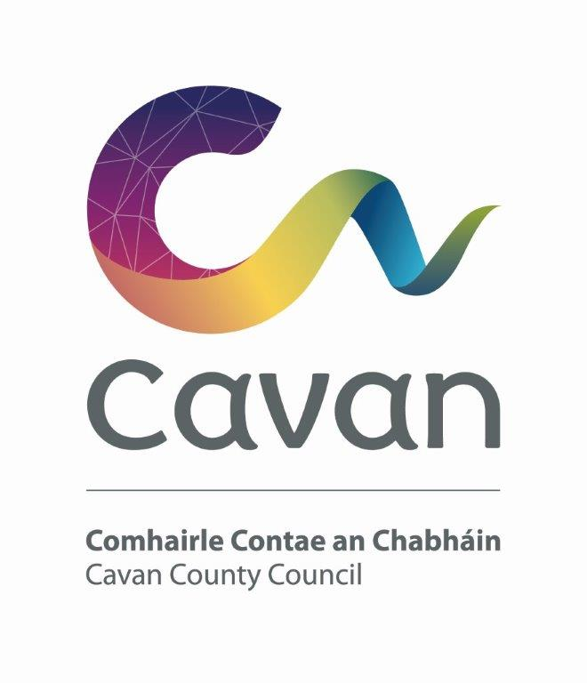

Cavan County Council

Cavan - Belturbet Municipal District

- Minutes of Meeting held on Tuesday 4th November in Dowra Courthouse, Dowra, Co Cavan

Presiding: (Cllr) Niamh Brady

Present: Councillors Brendan Fay, Áine Smith, John Paul Feeley, Patricia Walsh, Damien Brady.

In attendance: Paul Mulligan, SEE, Cavan Belturbet Municipal District Office
Brendan Jennings, Director of Services, Cavan County Council

Also in attendance:
Aiveen Devine, Clerical Officer, Minute Taker.

A G E N D A/ CLÁR

- Confirmation of Minutes

To confirm Minutes of Monthly Meeting held on the 15th of September 2025

- Disclosure of Interests (Section 177 Local Government Act 2001)

Business prescribed by Statute, Standing Orders or Resolutions of the Council

- Confirmation of Minutes

Cllr Smith proposed minutes of last meeting and Cllr Feeley seconded.

Matters arising from previous meeting - Letter sent to Uisce Eireann re: Milltown and we are awaiting response.

- : Executive Items-

- Adoption of Cavan/Belturbet Municipal District Draft Budget 2026

Description | Service | Subservice | Euro
Housing Estate Grants | A01 | A0104 | 25,000
Festival Grants | D06 | D0601 | 7,000
Environmental Grants | E05 | E0502 | 7,000
Playgrounds | F03 | F0302 | 22,200
Community Grants | F04 | F0401 | 10,000
Discretionary Amenity etc | F03 | F0301 | 125,000
Total |  |  | 196,200

Brendan presented Adoption of Draft Budget 2026
Proposed by Cllr Feeley, Seconded Cllr P Walsh

6. Road Works Programme update Paul Mulligan
Mr Mulligan presented his report speaking about completion of all Restoration improvement works and surface dressing as seen in table.

- Restoration Improvement Programme 2025
Road Class | Road Number | Road Name and Location | Source | Description of Works | Percentage Completed
R | R-200-3 | Bellavally to Carty’s Bridge / Glangevlin | RI | Road Reconstruction | 100%
Road Class | Number Road | Road Name and Location | Source | Description of Works | Percentage Completed
LS | L-6036-0 | Killynebber | RI | Road Reconstruction | 100%
LT | L-60361-0 | Reservoir Road | RI | Road Reconstruction | 100%
LS | L-5586-0 | Kilmore Upper / Danesfort (Drumhecknagh Rd) | RI | Road Reconstruction | 100%
LT | L-55321-0 | Drumard / Derryniggan, Cavan | RI | Road Reconstruction | 100%
LT | L-15121-0 | Drumard Road | RI | Road Reconstruction | 100%
LT | L-15122-0 | Drummullan | RI | Road Reconstruction | 100%
LS | L-5515-0 | Kilconny-Raheelan, Belturbet (Phase 2) | RI | Road Reconstruction | 100%
LP | L-1069-0 | Whitefield Cross to Ardlougher (Phase 1) | RI | Road Reconstruction | 100%
LP | L-1029-0 | Corracomera Road (Corlough Church Road) | RI | Road Reconstruction | 100%
LP | L-5046-0 | Cloneary | RI | Road Reconstruction | 100%
LS | L-50451-0 | Gortaclogher | RI | Road Reconstruction | 100%
LP | L-1008-0 | Corratober Upper | OR RI | Road Reconstruction | 100%
LP | L-1501-0 | Barrack Hill, Belturbet | Add. RI | Road Reconstruction | 15%

Mr. Mulligan confirmed that works at Aldi Roundabout in Cavan were due to finish tonight and all other Restoration works are now completed. The only exception is Barrack Hill, Belturbet and Mr. Mulligan thanked the members for approving these additional works.

Mr. Mulligan thanked Ciaran McTague and all the men involved for assisting with nightworks on the Former National Road R212, this meant very little interruption to the public and works ran very smoothly. He also complimented Keenans for their excellent work.

Mr. Mulligan also complimented Seamus O’Brien and Martin Smith for works on bridge at Mullaghboy and Susie’s Elbow and the McCabe Group for their excellent works. He also thanked John McKernan and Paddy Connaughton for organising funding for emergency works at Susie’s Elbow. The footpath to Farnham had been ongoing for years and he complimented the Active Travel team, landowners and Sammy Wilkins on a fantastic job.

In relation to the upcoming projects Mr. Mulligan stated that sectional repairs at the entry to the Army Barracks have been completed but resurfacing the road in future is needed. Cllr. Walsh agreed that these works need to be done and Cllr. Smith also agreed as has become very dangerous. Mr. Mulligan said that they will do what they can when funding is available.

Cllr. Smith complimented Mr. Mulligan with a great report and thanked him and his team for all works completed. Cllr. Walsh also complimented Mr. Mulligan and team and especially for traffic management. Cllr. Fay complimented Mr. Mulligan on works done on the Glangevlin to Dowra Road. He also stated that although a lot of roadworks were ongoing in Cavan at the same time and complaints received, they were dealt with professionally and the public are very pleased with the work done. Cllr. Damian Brady also complimented Mr. Mulligan and all outdoor and indoor staff on excellent works completed but mentioned that with three jobs ongoing on all access routes into Cavan town if it was at all possible in the future to coordinate at different times. Cllr. Feeley also complimented Mr. Mulligan and team.

7. Members Items:

7.1 Councillor Walsh
Broadband issue at Drumconnick, Cavan.
Cllr Walsh spoke to residents and suppliers informed them that they could wait over a year and a half for broadband. Mr. Mulligan suggested that they ring around different suppliers as multiple suppliers available now and gave an example of Arden as they have provided access in the most rural areas. Mr. Jennings said he could also mention to Daniel in IT and ask him to make some calls, but it did not make sense that anyone would have to wait that length of time as County Cavan is now well supplied. Mr. Mulligan agreed to speak to Arden as an alternative supplier and revert to Cllr. Walsh.

7.2 Councillor Walsh
Illegal Dumping
Cllr. Walsh stated that illegal dumping has become a nightmare throughout the county, she complimented Marie Morgan and her team on their tremendous work but within a few weeks of clean ups dumping is as bad as ever again. Cllr. Fay stated that vacant houses in council estates and private estates is a major problem and that people need to be made an example off when caught dumping illegally. Cllr. Damian Brady suggested that boarding up vacant buildings may deter dumping. Cllr. Fay requested that we confirm how much money is spent on Waste Management.
Cllr. Walsh proposed that we install bins in Council houses and add onto rent, Mr. Jennings agreed to speak to Lynda in relation to this proposal. Cllr. Walsh also proposed that anyone that did not have bins would show receipts at from the landfill to confirm they disposed of their waste. Cllr. Niamh Brady proposed that an instant fine be introduced.
All Councillors support the motion.
Mr. Jennings will speak to Waste Management team and agreed that our biggest failure was not finding the predators but with GDPR it is becoming increasingly difficult.

7.3. Cllr Á Smith & Cllr Fay
Footpath Extension from Drumlark Road to Ballymackinroe Lane (and Coolboyogue Road)
Cllr. Smith stated that there this road is narrow and dangerous with no safe place to walk and urgently requires safety improvement plans. Cllr. Fay mentioned that there are at least fifty houses at this location and something needs to be done to partially alleviate the problem.
Cllr. Feeley supported the motion and mentioned that it was on the agenda last year, but it was hoped that it could become part of the Greenway and Cllr. Feeley asked where works were at in relation to the Greenway. Mr. Mulligan confirmed that they were a long way off as TII oversees Greenways and a lot of procedures must be adhered too.
All Councillors supported the motion.
Mr. Mulligan said unfortunately there are no proposals to alleviate the problem at present as the Greenway is the only possible solution.

7.4 Cllr Á Smith
Flooding on our roads
Cllr. Smith mentioned that flooding has become a very scary problem for a lot of people as they have been stuck in their houses with no access to or from their homes, for example in Borim, Derrymoney, Gurteen and many areas throughout the county. This will only become a wider problem with climate change and a huge problem with electric cars as they automatically stop when they come to a flood.
Mr. Mulligan stated that the Ballyconnell Ballinamore Drainage committee dealt with all drainage problems and alleviated these problems but unfortunately it is no longer in place. Cllr. Damian Brady agreed that this committee was brilliant and it was a shame it was gone. He mentioned that keeping gullies cleared was essential in preventing flooding and it was suggested that Cavan/Belturbet MD invest in a sweeper of their own. Cllr. Feeley suggested that we apply for Climate Action Funding again and see what we can do within reason with money allocated for Drainage Board.
All Councillors support the motion.
Mr. Mulligan thanked everyone for their points and stated that unfortunately with issues with fisheries, etc. it is not a matter of going in with a digger and clearing silt/debris as was done before as was done when the Ballyconnell Ballinamore Drainage committee was in place. Mr. Mulligan agrees that keeping the gullies cleared is very important, but it is difficult to get contractors and, in some cases, when gullies are cleared, they block again very quickly with debris, however it may merit purchasing our own jetter/sweeper. Mr. Mulligan said he will take all comments on board.

7.5 Cllr Fay
The upkeep of some footpath’s hedges cut back, and footpaths cleared as people are getting cut with briars and dangerous paths having to move on to the busy roads in the Belturbet & Killeshandra towns areas
Cllr. Fay thanked Mr. Mulligan and team for all works done in relation to the concerns on the Carrigallen Road in relation to hedges. He mentioned that there are still a lot of overgrown hedges in our towns and villages and commented that Tidy Towns are doing a fantastic job. He asked if any other solution apart from hedge notices. Cllr. Brady agreed and explained that it encourages people to go for a walk and important to keep our footpaths clear.
Cllr. Smith mentioned that lights are needed at the garage in Belturbet and at Tesco Cavan.
All Councillors support the motion

7.6 Cllr Feeley
Ongoing flooding issues, need for coordinated action to address issues

Discussed in 7.4 while discussing flooding on roads.
All Councillors support the motion

7.7 Cllr Feeley
Dublin Road Roundabout N3/N55
Cllr. Feeley mentioned that Public Consultations have been taking place for over 2 years now and that this Roundabout is not a good image entering our county town.
All Councillors support the motion.
Cllr. Walsh mentioned the Swellan area has become extremely dangerous, Mr. Jennings stated that there was a Transport Assessment done earlier today in relation to Swellan. Mr. Mulligan mentioned that he has spoken with Road Design about the Dublin Road Roundabout and Safety Scheme, and they realise the urgency here, he will speak to them again, but the design and composition of the roundabout will have to be considered. Mr. Mulligan feels that another bypass may be the only solution.

7.8 Cllr Niamh Brady
The speed of traffic going through Butlersbridge
Cllr. Niamh Brady mentioned that all vehicles, especially trucks enter the village from the Clones Road at high speeds and there is a Primary school and football pitch leaving it extremely dangerous. The presence of speed ramps would help but Mr. Jennings mentioned that the TII will not allow them on a National Route. Cllr. Feeley recalled funding for a pedestrian crossing here but Mr. Mulligan felt that people would not walk out of the town to use a pedestrian crossing and back again but suggested the possibility of a raised crossing.
All Councillors support the motion.

7.9 Cllr Damien Brady
Derrymoney Lane

Discussed in 7.4 while discussing flooding on roads.
All Councillors support the motion

7.10 Cllr Damien Brady
Gully cleaning and Drainage in our MD

Discussed in 7.4 while discussing flooding on roads.
All Councillors support the motion

AOB
Cllr. Fay mentioned that the Halloween Festival was a great success in Belturbet and wanted to thank Donnie McAvenue GSS and all men involved in clean up and said they went ‘beyond their call of duty’. Mr. Mulligan thanked Cllr. Fay for the comments and assured to pass on to relevant staff.
Cllr. Feeley mentioned how important it was to hold the meeting in Dowra Courthouse today as its refurbishment was funded by Cavan County Council. He wanted to thank all the volunteers that help with the running of the Courthouse as it would not be there without their dedicated work. All present agreed with Cllr. Feeley and offered their gratitude for their hospitality.

Date for next meeting 13th of January in Trivia House, Swanlinbar at 3 O’Clock.

Meeting closed 5.20

Signed:------------------------------------------------------------

Date:--------------------------------------------------------
.

