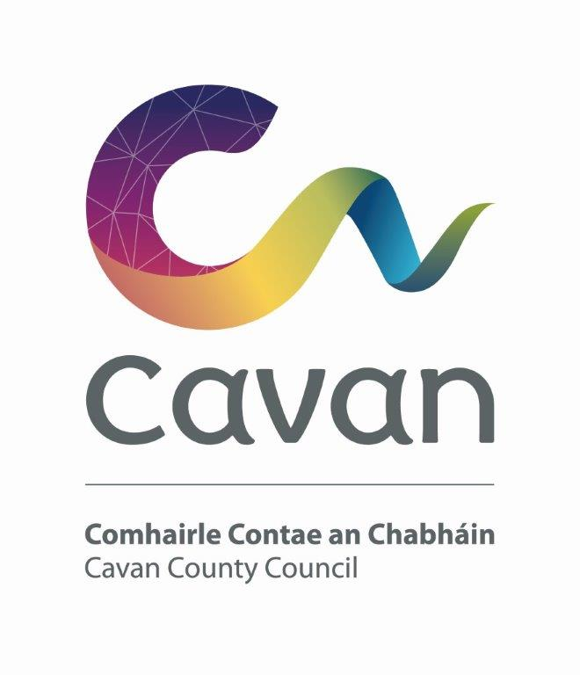

Cavan County Council

Cavan - Belturbet Municipal District

Minutes of Meeting held on 15th July 2024

Presiding: Councillor (Cllr) Patricia Walsh, Cathaoirleach

Present: Councillors John Paul Feeley, Brendan Fay, Niamh Brady, Damien Brady and Áine Smith.

In attendance: Paul Mulligan, SEE, Cavan Belturbet Municipal District Office
Brendan Jennings, Director of Services, Cavan County Council

Also in attendance:
Seamus Enright, Anglo Celt.
Rosaleen Higgins, Assistant Staff Officer, Minute Taker.

A G E N D A/ CLÁR
- Confirmation of Minutes

To confirm Minutes of Monthly Meeting held on the 22 April 2024.
- Disclosure of Interests (Section 177 Local Government Act 2001)

Business prescribed by Statute, Standing Orders or Resolutions of the Council

- Confirmation of Minutes
Cllr Smith proposed minutes of last meetings and Cllr Fay seconded.

Cllr Walsh welcomed and congratulated the new councillors and expressed her hard luck to Peter. He was a hardworking Councillor and will be missed by all in Ballyconnell. She wishes him the best and suggested we write a letter to him expressing our thanks and thoughts with him.

All councillors expressed their sadness for Peter and wished him well.

Cllr Walsh also expressed her sadness at retirement of Madeleine and wished her well, she also said we will send her a letter of thanks.

Mr Jennings also said he was sad to see them both go. Said it was hard for Peter, he was a “good man”. He welcomed the new councillors.

Cllr Walsh welcomed Cllr Niamh and Cllr D Brady. She said we work as a team to get things done.

Cllr D Brady wished Mr Derry Scanlon the best of luck in his upcoming retirement. All councillors wished him well,

Mr Jennings also wished Derry well, he said the was good to him when he started in the council. He was in Cavan Belturbet MD a long time, and nothing phased him.

Cllr Walsh also congratulated the U16 Girls football and Camogie teams on winning all Irelands.

Cllr Smith also congratulated the teams especially Sarah Devine captain of the Camogie team and on the football teams.

- Executive items

- Road Works Programme update Paul Mulligan
Mr Mulligan presented his report along with photos which were admired by all, showing the outgoing works which included the following restoration works:
A Drumgola- Coolboyoge (Lorteto Rd to N3)- he mentioned how when they excavated the road, they removed soft area and resurfaced the road.
B Creenagh Glebe, drainage ongoing on this road.
C Raheelan-Greathill drainage to be completed by next week, Mr Mulligan stated.
D Killymoriaty- Macadam layed.
E Kilsob toward Templeport Dense Bitumen Macadam Completed
F Tullynafreave- Drainage ongoing. Mr Mulligan stated that “drainage all worth it, never wasted”
G Drumcrow, Butlersbridge- Macadam completed.
He also spoke of the Surface Dressing recently completed.
Up coming projects includes LIS at Shankill and another one in Glangelvin.
All councillors complimented Paul’s report including the very professional photos.
Cllr Fay mentioned great job at Derryhoo bridge, residents delighted with job.
Cllr Smith said driving the roads, shows great job done especially Killymoriarty
lots of compliments from the local people.
Cllr D Brady mentioned it was great for outdoor workers to get compliments. He complimented the surface dressing, saying it is the best job Council does. Money well spent.
He asked who is responsible for Bridges, bridge at Swanlinbar water overflowing.
Cllr Feeley apologised for arriving late to meeting. He complimented the outdoor staff on Surface Dressing. He said hedges need to be cut for people out walking and cycling.
Cllr Walsh asked when Swellan Court, Glenside and Patrick Tce, would be done. Mr Mulligan replied end July.

Mr Mulligan stated we received 269K in extra funding. He said we looked at all roads and proposes we restore Drumalee Rd out to Breffni College. 1 KM of road, it fits in with the budget and the timeframe. Works would be carried out during the Halloween break.

Members Items
1. Sewerage in Milltown Cllr Smith
Cllr Smith stated that Milltown was a top-class village, great child care facility, playground and school. It needs an up-to-date sewerage scheme. She received many calls about it and wants to know, can something be done.
Cllr Feeley supports the motion stating that the sewerage in Milltown is a bone of contention, tanks must be emptied every few weeks. He is disappointed it is not included on scheme for small villages. He has emailed P Connaghton and team for funding.
Cllr D Brady supports motion, very busy village, poor sewerage system main topic on doorsteps in election.
Cllr Fay spoke of bad smell. He has over 500 names on petition and Eircode’s for all. Why was the application rejected? He spoke to M Mussi about it.
Cllr Walsh also supports motion, she spoke of active community in Milttown, they entitled to proper sewerage system.
Mr Mulligan stated, all they said was correct. He suggests Mr Mussi submits application again when it opens.
Cllr Smith thanked all for support for her motion and suggested writing to Irish Water and a meeting with staff.

2. Parking bays and parking meters in Cavan town. Cllr Smith

Cllr Smith said parking problems an issue in Cavan Town. Delivery drivers find it hard to pull up. Can a parking bay be put aside for deliveries on main street?
Also, the parking meters at Tesco carpark, beside St Clares church was card only and causing a problem as sometimes would not connect.
All councillors supported the motion and concurred that delivery drivers were finding it difficult.
Mr Mulligan said they could be fined for parking on footpath. He suggested liaising with the Chamber of Commerce.
Mr Jennings said every town struggles with this. Van drivers need to be flexible with deliveries.

- Signage at Derrygoss, Butlersbridge Cllr Walsh
Mr Mulligan said there is signage. Cllr Walsh said lorries are ignoring it. Curbing broken and walls cracked at peoples houses because of traffic.
A large sign is needed.
Mr Mulligan said perhaps we could “beef it up”
All councillors supported the motion.

- Safety Measures on the N87 at Cranaghan Cllr D Brady
Cllr Brady said that four cars one after another had left the road and driven straight into the field. Also, he expressed concern at the 90 Degree bend at Ballyhugh and asked for a barrier to be erected. And maybe a non-slip surface at Killnagher Church at N87.
All councillors supported the motion.
Mr Mulligan replied that Road Design looked at bends in question and they said there were crash barriers there before, but they are now considered to be a hazzard in that they can push a crashing vehicle back into traffic. The main objective is to save life said Mr Mulligan.

- Traffic calming on the Derrylin Road, Ballyconnell Cllr Feeley
Cllr Feeley said he has had numerous queries about this. There is a lot of estates there. Footpath should be continuous into the town. People need to be safe walking into town. He suggested a roundabout, ramps, pads or strips to slow traffic down.
All councillors support the motion.
Mr Mulligans replied funding sought for this twice and not successful. But he will apply again.

6 Traffic calming Moynehall, Cavan Cllr Feeley
Cllr Feeley says residents cannot get out onto the road because of the speed of traffic. He asked if there were any plans for Active Travel measures on that road.
Cllr Fay asked can people be diverted another way.
Cllr Walsh said serious concerns, hard to cross the road, it is a nightmare.
Cllr N Brady said there was a lot of road rage, people tooting horns trying to force people out onto road.
All councillors support the motion.
Mr. Mulligan said it was under review with Road Design and he will come back to them at the next meeting.

Signed:----------------------------

Date:-----------------------------------

