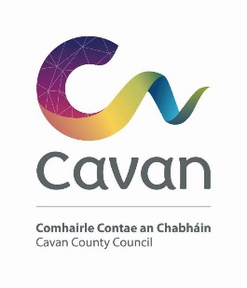
07 Eanáir 2026

Comhairle Contae an Chabháin

Ceantar Bardasach An Cabhán - Béal Tairbirt

A Chathaoirligh agus gach baill den Ceantar Bardasach.

A Chomhairleoir,

Beidh an chéad cruinniú Ceantar Bardasach An Cabhán – Teach Tráth na gCeist Swanlinbar
13 Eanáir 2026 ag 3 i.n.

Tá an clár ar an thaobh eile den laethanach.

Is mise le meas,

Riarthóir cruinnithe.
Rosaleen Higgins.

Cavan County Council

Cavan Belturbet Municipal District

07/01/26

To Cathaoirleach and Each Member of The Cavan Belturbet Municipal District

Dear Councillor,
The next meeting of Cavan Belturbet Municipal District will be held in Trivia House, Swanlinbar.
- On Tuesday the 13th of January at 3pm
.

The agenda is overleaf.

Yours sincerely

__________________
Meetings Administrator

A G E N D A/ CLÁR
- Confirmation of Minutes

To confirm Minutes of Monthly Meeting held on the 04^{th of} November 2025

- Disclosure of Interests (Section 177 Local Government Act 2001)

- Correspondence-

Business prescribed by Statute, Standing Orders or Resolutions of the Council

- Executive Items-

- Road Works Programme update Paul Mulligan
7. Members Items
7.1 Councillor D Brady
Salting of Roads in our MD area.

7.2 Councillor D Brady

Heavy Traffic through Ballyconnell.

7.3 Councillor Feeley

That CCTV be installed at the playground in Con Smith Park.

7.4 Councillor Á Smith

Problems with vehicles speeding on approach road from Belturbet to Killeshandra at Lake View.

7.5 Councillor Á Smith

Need to expand Winter Gritting Programme.

7.6 Councillor Fay
Road salting especially around our Schools.

7.4 Councillor Walsh
Potholes in Tesco Carpark
Safety concerns in relation to Fireworks on New Years eve.

AOB
Date of next meeting.

