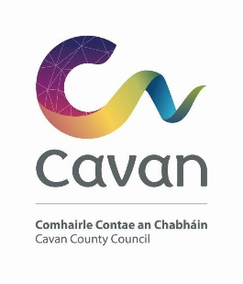

Cavan County Council

Cavan Belturbet Municipal District

13 September 2024

To Cathaoirleach and Each Member of The Cavan Belturbet Municipal District

Dear Councillor
The next meeting of Cavan Belturbet Municipal District will be held in the Townhall Belturbet-
- On Friday 20th September.
.

The agenda is overleaf.

Yours sincerely

__________________
Meetings Administrator

A G E N D A/ CLÁR
- Confirmation of Minutes

To confirm Minutes of Monthly Meetings held on the 15^{th of} July 2024.

- Disclosure of Interests (Section 177 Local Government Act 2001)

- Correspondence- None
Business prescribed by Statute, Standing Orders or Resolutions of the Council

- Executive Items- None.

- Road Works Programme update Paul Mulligan

Members Items
- Teenagers/Childrens amenities Cavan Town Cllr N Brady
- Playground at Killykeen Cllr N Brady

- Carrickane Rd from Loreto Cross to Hospital Cllr Á Smith

- Works needed at junction at Sheehans and road to graveyard in Kildallan Cllr Á Smith

- Outdoor facilities at lock No 2 Ballyconnell Cllr D Brady

- Greenway connecting Corlough Gaa grounds with Corlough School and Chapel Cllr D Brady

- Upgrade of the Tractamotors Junction, Cavan Town to address the on-going delays for traffic and the disruption to local residents. Cllr Feeley\Cllr
Walsh

- That Cavan Belturbet MD call on the TII to review safety on the junctions on the M3 from the Aghalane Bridge to the Dublin Road Roundabout. Cllr Feeley

- Road safety measures in the Swellan area i.e. footpaths and crossings.
Cllr Walsh

- To ask Council to write or collaborate with An Post to see what can be done to upgrade or clean up the historic old post office on Main Street Belturbet. Cllr Fay
11. To ask Cavan County Council to see can a crosswalk be put in Butlersbridge, at the graveyard, housing estate across to the GAA pitch. As major safety concerns with children. Cllr Fay

AOB

