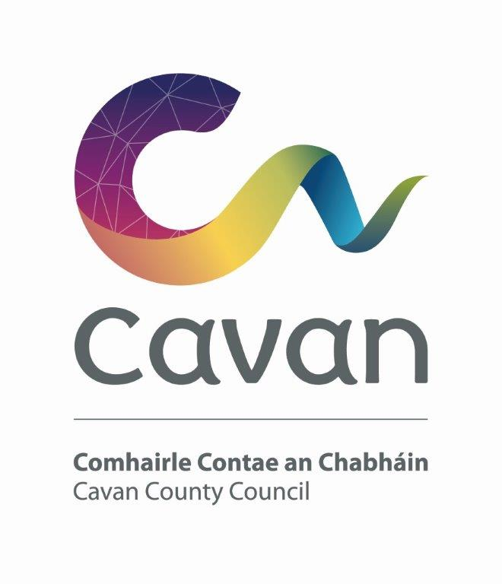

Cavan County Council

Cavan - Belturbet Municipal District

Minutes of Meeting held in Trivia House, Swanlinbar on Tuesday the 13th of January 2026 at 3pm.

Presiding: (Cllr) Niamh Brady

Present: Councillors Áine Smith, John Paul Feeley, Damien Brady.
Apologies from Councillor Brendan Fay

In attendance: Paul Mulligan, SEE, Cavan Belturbet Municipal District Office
Brendan Jennings, Director of Services, Cavan County Council

Also in attendance:
Rosaleen Higgins, Assistant Staff Officer, Minute Taker.

A G E N D A/ CLÁR
- Confirmation of Minutes

To confirm Minutes of Monthly Meeting held on the 04^{th of} November 2025
- Disclosure of Interests (Section 177 Local Government Act 2001)

Business prescribed by Statute, Standing Orders or Resolutions of the Council

- Confirmation of Minutes
Cllr Feeley proposed minutes of last meeting and Cllr Walsh seconded.

- : Executive Items-
None

5. Road Works Programme update Paul Mulligan
Mr Mulligan presented his report stating that all road works were completed for 2025.
The cover photo showed job at Derrymoney, a great job said Mr. Mulligan.
He mentioned the excellent job done at Barrack Hill Belturbet and picture on page 4
showed completed surfacing and line marking at R-197 Junction.
Mr. Mulligan mentioned the Climate Adaptation Scheme – R-200-0 Kilduff Middle – completed. The bridge parapet was repaired and chevrons erected.
Mr. Mulligan mentioned the job on the Former National Road R212 – Tractamotors to Aldi. We received several compliments in relation to a great job done.
Mr. Mulligan in his report had more photos of the job at Derrymoney. He thanks Mr Connaughton for the funding to complete the job. He said there was no quick fix. When the road resettles, it will go down, it is on a marsh. He said there should be a separate road for Coillte as agreed but it was never followed through.
Cllr Walsh asked can Coillte now use the road. Mr. Mulligan replied that they need permission to do so.
Mr. Mulligan mentioned the upcoming projects are as follows:
- Drainage Remedial Works
- Winter Maintenance
- Commencement of Restoration Improvement Schemes 2026.

2026 Schemes from 2025-2027 RI Programme
 | R | R--212-1 | 6/7 | Ballyhaise Road, Cavan
 | LT | L-15083-0 | 4 | Derryna Lane (Tirliffin)
2026 | LP | L-1059-0 | 6 | Whitefield Cross to Ardlougher - Phase 2
 | LT | L-10493-0 | 4 | Derrycassan
 | R | R-207-0 | 6 | Dowra to Blacklion Road
 | LS | L-1025-0 | 5 | Eagle Hill Road

Cllr N Brady thanked Paul for a job well done and complimented his great photos.

7. Members Items
7.1 Councillor D Brady
Salting of Roads in our MD area.

Cllr Brady mentioned over the last two weeks there was lots of frost and a lot of the roads very treacherous. He asked can we not salt all roads. He mentioned the following:- Dowra to Blacklion, Smiths Cross out to McLoughlin’s shop, Kildalan and Miltown.
He said some of these roads used to be done with the small gritter and were on the programme and why are they not now?
Cllr A Smith agreed, her phone was hoping with calls about salting. She does understand we are better at salting than some other counties. We treat 650 KM of road.
Still getting calls especially from schools. Can we liaise with schools to inform them to purchase a salt bin themselves.
Cllr Smith complimented the outdoor staff; she appreciates the work they do. They put their lives at risk going out early in the morning.
Cllr Feeley also complimented staff on the job they do salting. He said it was especially bad around Dowra Mart; it is never salted. He complimented some of the schools that took the decision to close, so lives would not be put in danger.
He said driver behavior is a problem. He observed cars beeping horns because cars were going to slow in the frost. He said around where he lives, roads were gritted. He said we need to look at Glangelvin and N16. He appreciates salt not a magic powder and roads are dangerous. He again thanked staff for their good work. He asks if we can look at engaging outdoor contractors for salting if our crew are off on rest days.
Cllr Walsh also complimented staff and the residents in housing estates for doing it themselves.
Cllr N Brady also complimented staff, mentioning when gritter passing, can it spray some salt in junction at Drumsilla motors.
Mr. Mulligan replied, he said no matter what we do it will not be enough. We do 650km of road and we do what we can locally. Our mini salter covers part of the main routes. If we completely focus on salting what happens with our other jobs. We must comply with the Working Time Act for rest days. We have a Microclimate in this district for example the R200 and R207 was salted and refroze. None of those roads requested are on a program. Why should one road be done before another road. We try and be reactive to where there is a problem.
Mr. Mulligan complimented locals and staff for the work they do in keeping the roads clear.
Cllr Feeley mentioned it would merit a post on social media that even though salted done there is still a need for caution, roads still dangerous and maybe close schools.
Cllr A Smith said it depends on the principal of a school whether schools close or not.
Cllr Walsh said principals should think about the safety of students and staff.
Cllr D Brady complimented staff risking their lives.
7.2 Councillor D Brady

Heavy Traffic through Ballyconnell.

Cllr Brady talked about the HGV traffic going through Ballyconnell. We have an inner relief road he said but traffic still coming through the town. He asks can we do something. He says there is a sign that needs replacing. He mentioned one lorry caused damage to the Christmas Lights.

Mr Mulligan replied that he will check sign but not sure if it will make a difference, it is all down to driver behaviour.

7.3 Councillor Feeley

That CCTV be installed at the playground in Con Smith Park.
Cllr Feeley asked when we are moving ahead with CCTV at Con Smith Park.
Mr Mulligan replied that himself and Siohban Sheils are working through the paperwork associated in getting it up and running.
Mr Jennings also said we are working on it.
Cllr N Brady said concerned residents are asking if they could set up friends of Con Smith Park committee.
Mr Jennings replied that it is a public park, so we mange it. User groups could keep their eyes and ears opened.
Cllr Walsh expressed her disbelief at vandals cutting locks of the playground.
Cllr N Brady asked were the basketball courts vandalised. Mr Jenning said no, the contractor was called back to replace the courts. Cllr Feeley said not unusual for items to be broken in public place.

7.4 Councillor Á Smith

Problems with vehicles speeding on approach road from Belturbet to Killeshandra at Lake View.

Cllr Smith said the traffic is speeding around tight bend beside Trainers going uphill. She witnessed the activity herself.
Can a speed survey be done, she asked.
All councillors supported the motion.

Mr Mulligan replied yes, we can get survey done but again it is down to driver behaviour. He mentioned Killeshandra town is getting full of speed ramps.

Cllr Smith said the ones at Farnham are brilliant.
Mr Mulligan said when they get across the ramps and speed up again.

7.5 Councillor Á Smith

Need to expand Winter Gritting Programme.

Discussed under 7.1.

7.7 Councillor Walsh
Potholes in Tesco Carpark
Cllr Walsh asked were the potholes in Tesco Carpark addressed.
Mr Mulligan replied yes, they were but a much bigger job is needed, and we are looking at it. Funding is an issue, but it needs to be done.
Mr Jennings said we are looking at a revamp, its time to develop town centre. A proper job will be done sometime in the future.
Cllr Walsh went on to say it is difficult to exit your car on hill in carpark.
Mr Mulligan said potholes are everywhere, the surface is passed its life. Where do we start and finish. We need to strive for the best we can do.
Cllr Walsh delighted that Penney’s coming in as a lot of people leave the town to shop in Penney’s.

7.8 Councillor Walsh
Safety concerns in relation to Fireworks on New Years eve.
Cllr Walsh said on New Year’s Eve, people were letting off fireworks in housing estates. Cars and houses were damaged and some children were terrified. She askes can we put it up on Social Media warning about fireworks. Can we send out a letter saying about the dangers off fireworks.
Mr Jennings said he will check with the Media Correspondent Conor Harrington.

Date of next meeting fixed for Monday 9th March at 10.30.

Signed:------------------------------
Date:---------------------------

