
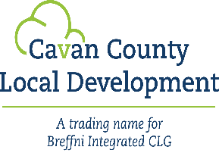


OUTDOOR RECREATION INFRASTRUCTURE SCHEME 2026/2027
Measure 1 (up to €40,000) - Expression of Interest Form for
Community & Voluntary Groups
The Outdoor Recreation Infrastructure Scheme (ORIS) supports the development of new outdoor recreational infrastructure and the necessary repair/maintenance, enhancement or promotion of existing outdoor recreation infrastructure in country- side areas across Ireland.

Local Community Group Information
Community Group:
Contact Person:
Position:
Email:
Telephone No.:
List any other stakeholders involved in this application:

Project Information
Estimated Project Costs

Funding Requested

Please provide a short, and concise description of the proposed project:
Max 100 words
Project Type: New project or maintenance/upgrade of an existing project:
If the project is a trail, is the Trail currently on the Trail Register? Yes/No
Has this project, or part of, previously received funding?
If so please outline:
Is there any other funding application pending for this project?
If so please outline:
Location of proposed works: Include nearest town/village:

Please provide the Eircode if possible or XY (ITM format) co-ordinates of the project: | EIRCODE  XY (ITM)
  E |  |  |  |  |  |  |  | N
Or please provide a map (if applicable) showing the location of the project

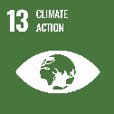
Please confirm if planning permission/ planning consent is required. Please note that if the project is selected to be submitted that this must be in place at time of application.
If planning permission is not required, please advise why:
Do you own the land or have the written consent of the landowner?
Is the project located on Coillte or NPWS lands?
If yes, please provide written consent of the landowner, detailing the agreed project

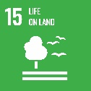
Is the project located in a Special Area of Conservation (SAC) or designated site [Check here ]

If yes, or it impacts upon a designated site, have appropriate screenings and assessments been completed or are they in progress

Outline how the project supports climate action and/or biodiversity:
e.g. tree/hedgerow planting on trails, native pollinator plants on trails, cycleways, etc.
Has this project been discussed with Biodiversity and/or Heritage Officer

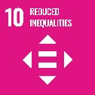
Outline how the project will support an inclusive approach or enhance opportunities for people with disabilities
Is or will this amenity free of charge to the public?
Are these works part of a larger project:

Please provide a full description of the proposed project and the works involved (max 500 words)

How will you provide for the ongoing maintenance of the project?

How will the project impact the local area:

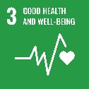
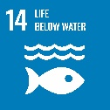
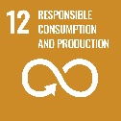
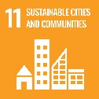

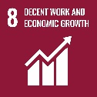

How will the project support tourism in the local area:

Outline what are the overall objectives of the proposed project (up to 5 bullet points)

5.

How will the intended outcome be measured (up to 5 bullet points):

2.
3.
4.
5.

Detailed Costings for Proposed Project:
Please provide detailed breakdown of all elements of the proposed works including any professional/other fees/costs:
Project Elements*  (provide details of each element) | Cost (inc. VAT)
 | €
 | €
 | €
 | €
 | €
 | €
 | €
 | €
Professional fees  (e.g. architectural, engineering, survey costs) | € | % of total project cost:
Total Project Cost | €
Grant Aid amount sought.  (Max of 90% of total project costs) | €

Timelines:
If successful, how long will it take to deliver this project?

Indicative time frame:
(Weeks/Months)

Signed on behalf of _______________________ (Lead Applicant Organisation)

Name in Block Capitals____________________

Date___________________________________

