.
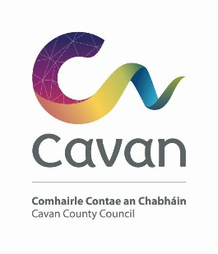

Cavan County Council

Cavan Belturbet Municipal District

16th January 2024

To Cathaoirleach and Each Member of The Cavan Belturbet Municipal District

Dear Councillor
The next meeting of Cavan Belturbet Municipal District will be held in the Courthouse Cavan.
- On Monday 22nd at 3.30pm in the Council Chamber.

The agenda is overleaf.

Yours sincerely

__________________
Meetings Administrator

A G E N D A/ CLÁR
- Confirmation of Minutes

To confirm Minutes of Monthly Meetings held on 6th November 2023 and 13 November 2023.
- Disclosure of Interests (Section 177 Local Government Act 2001)

Business prescribed by Statute, Standing Orders or Resolutions of the Council
- Road Works Programme update Paul Mulligan

Members’ Items

- Safety measures at Cafferty’s cross and Smith’s of the cross.

Cllr Smith
- Salting routes. Cllr Smith

- The urgent need to carrying our realignment/safety measures on the Crossdoney Rd, Cavan Town. Cllr Feeley

- That we look at the safety concerns in the N3 Belturbet Bypass especially at the old Belturbet Rd (lighting) and Putighan (turning lanes) and the general speed.
Cllr Fay

- That we look at the feasibility of a bus stop in or around the old post office area at Poles, Cavan. Cllr Fay

- Swanlinbar HSE Clinic- why is it not opened on a Friday.
Cllr Mc Vitty

- Seating for patients outside Cavan General Hospital
Cllr Mc Vitty

- Taxis in Cavan Town. Cllr Walsh

