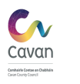

STAGE 1: SCREENING FOR APPROPRIATE ASSESSMENT

PURSUANT TO ARTICLE 6 (3) OF THE HABITATS DIRECTIVE 92/43/EEC ON PLANS & PROJECTS SIGNIFICANTLY AFFECTING NATURA 2000 SITES.

Plan or Project:
VARIATION NO. 1 CAVAN COUNTY DEVELOPMENT PLAN (2014 – 2020)

STAGE ONE: SCREENING

INTRODUCTION
  - Requirement for Appropriate Assessment (AA)
This Screening provides information on the potential for the proposed Variation No. 1 Cavan County Development Plan 2014 – 2020 to impact on designated sites of conservation importance within a European context.
Proposed Variation Number 1 of the Cavan County Development Plan proposes the following change to the plan in question.
Seeks in accordance with the Urban Regeneration and Housing Act 2015 to integrate specific objectives which will identify and encourage the development and renewal of identified areas in need of regeneration or residential development and to specify the areas identified in need of regeneration or residential development

1.2 Legislative Background to Appropriate Assessment
European Directive 92/43/EEC (The Habitats Directive) requires competent authorities to carry out an Appropriate Assessment (AA) of plans and projects that, either alone or in combination with other plans and projects are likely to have a significant effect on European designated sites.
The preparation of Variation No. 1 Cavan County Development Plan has regard to Article 6 of the Council Directive 92/43/EEC of 21st May 1992 on the Conservation of Natural Habitats and Wild Fauna and Flora (as amended). Hereafter referred to the Habitats Directive. This is transposed to Irish legislation under the European Communities (Birds and Natural Habitats) Regulations 2011 and the Planning and Development (Amendment) Act 2010.

The European Communities (Birds and Natural Habitats) Regulations 2011 lists priority habitats and species that are of European and International importance and require protection. This protection is afforded through the designation of areas that represent significant populations of listed species within a European context (Natura 2000 sites). Areas designated for bird species are classed as Special Protection Areas (SPA), and areas designated for other protected species and habitats are classed as Special Area of Conservation (SAC). Species that occur in SPAs (Annex I of Birds Directive) or SACs (Habitats listed on Annex I and/or Annex II Species listed on the Habitats Directive) in which they are designated features have full European protection. Species listed on Annex IV of the Habitats Directive are strictly protected wherever they occur in the country, whether inside or outside a Natura 2000 site. Habitats that are equivalent to those listed, but not within SACs are still classed as priority habitats of international and national importance and under Article 27 (4(b)), the planning authority has a duty to avoid the pollution or deterioration of Annex I habitats.

The Habitats Directive specifies scientific criteria on the basis on which Natura 2000 sites must be selected and sets out various procedures and obligations in relation to the conservation objectives of those sites.

Articles 6(3) and 6 (4) of the Habitats Directive set out the requirement for an assessment of proposed plans and projects likely to significantly affect Natura 2000 sites.

Article 6(3) establishes the requirement to screen all plans and projects for likely impacts (referred to as a Stage 1: Screening for Appropriate Assessment) and to carry out further detailed assessment if required (referred to as a Stage 2: Appropriate Assessment):
Article 6(3): “Any plan or project not directly connected with or necessary to the management of the [Natura 2000] site but likely to have a significant effect thereon, either individually or alone in combination with other plans and projects, shall be subjected to an appropriate assessment of its implications for the site in view of its conservation objectives. In light of the conclusions of the assessment of the implications for the site and subject to provisions of paragraph 4, the competent national authorities shall agree to a plan or project only after having ascertained that it will not adversely affect the integrity of the site concerned and, if appropriate, after having obtained the opinion of the general public”

Stages in the Appropriate Assessment Process
The process of assessing Variation No.1 Cavan County Development Plan is a structured exercise with a series of steps. The stages proposed in the European Commission guidance are:

Stage One: Screening — the process which identifies the likely impacts upon a Natura 2000 site of a project or plan, either alone or in combination with other projects or plans, and considers whether these impacts are likely to be significant;

Stage Two: Appropriate Assessment — consideration of the impact on the integrity of the Natura 2000 site of the project or plan, either alone or in combination with other projects or plans, with respect to the site’s structure and function and its conservation objectives. Additionally, where there are adverse impacts, an assessment of the potential mitigation of those impacts;

Stage Three: Assessment of alternative solutions — processes which examine alternative ways of achieving the objectives of the project or plan while avoiding adverse impacts on the integrity of the Natura 2000 site;

Stage Four: Where no alternative solutions exist and where adverse impacts remain — an assessment of compensatory measures where, in the light of an assessment of imperative reasons of overriding public interest (IROPI), it is deemed that the project or plan should proceed.

This report provides a Stage 1: Screening for Appropriate Assessment and is intended to address all issues regarding Variation No. 1 Cavan County Development Plan 2014 - 2020 and the potential impacts on all Natura 2000 sites within 15km of Cavan County and allow Cavan County Council as the “Competent Authority” to comply with Article 6 (3) and (4) of the Habitats Directive 92/43/EEC.

PROPOSED VARIATION OF CAVAN COUNTY DEVELOPMENT PLAN 2014-2020

Description and Features of Variation

The Urban Regeneration and Housing Act 2015 which was signed into law in July 2015 is premised on addressing matters nationally in terms of regeneration and housing supply. The Act aims to encourage urban regeneration with an emphasis placed on facilitating increased activity in the residential sector. The Vacant Site Levy was introduced under the legislation, as a site activation measure which is required to be integrated as part of the planning process, in seeking to ensure that vacant or underutilised land in urban areas is brought into beneficial use, in order to prevent
- Adverse effects on existing amenities in such areas, in particular as a result of ruinous or neglected condition of any land
- Urban blight and decay
- Anti social behaviour, or
- A shortage of habitable houses or of land suitable for residential use or a mixture of residential or other uses.
In making provision for the Vacant Site Levy in development plans, the Urban Regeneration and Housing Act 2015 requires Planning Authorities in the first instance to incorporate mandatory objective(s) to support Urban Regeneration and also to indicate areas within the County to which the equitable application of the levy can occur.

2.2 Variation Screening Process
There is no restriction on when the screening of any plan or project likely to significantly affect Natura 2000 sites can take place. The screening is intended to provide a review of the variation and if the variation triggers the requirement for more detailed level of assessment (Stage 2: Appropriate Assessment) and which Natura 2000 sites will be affected. This screening process is undertaken during the preparation of Variation 1 of the Cavan County Development Plan 2014-2020 and serves to highlight particular impacts of the variation on Natura 2000 sites and provides scope for amending new policies that would have a direct conflict with the conservation objectives of Natura 2000 sites.

2.3 Proximity of Cavan Town to Natura 2000 sites.
The boundaries of Natura 2000 Sites in Cavan County and within 15km of the County boundary. are shown in Figure 1.

Figure 1. Natura 2000 Network included in the Screening for Appropriate Assessment.
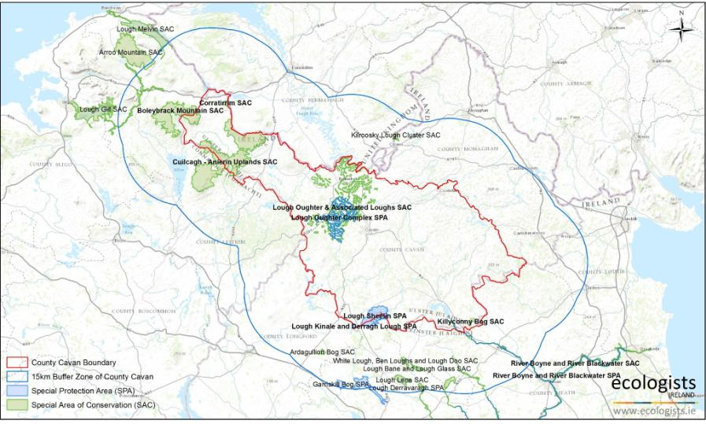

NATURA 2000 SITES

Overview of Natura 2000 Sites in Cavan County.
As shown in Figure 1, there are currently nine Natura 2000 sites designated for conservation interest within a European context. Five Special Areas of Conservation are designated within the County, including two sites that overlay the boundary, covering a total land area of c.16,600ha. Four Special Protection areas have been designated within the County, two of which overlay the boundary with a total land cover of c.4110.2ha.

Special Areas of Conservation in Cavan County.
The six SACs located within Cavan represent a diverse range of annexed habitats. The inter-drumlin network of wetlands and upland peatlands typical of the Cavan landscape comprise the core interest across the Natura 2000 network in the region. A broad guild of environmental conditions and associated habitats occur within Cavan County; from the botanically rich limestone pavement at Corratirrim, to the sparse arctic- alpine vegetation on siliceous rocky outcrops in the Cuilcagh-Anierin Uplands. The River Boyne and River Blackwater SAC is the only site designated for annexed species within the County, notably for nationally important populations of River Lamprey, Atlantic Salmon, and European Otter. Figure 2. Shows the location of all SACs in the County. Table 2 summarises the designated features of each site and indicates if the policies and objectives in Variation No. 1 Cavan County Development Plan 2014 – 2020 would have potential to exacerbate the existing pressures and threats to site integrity

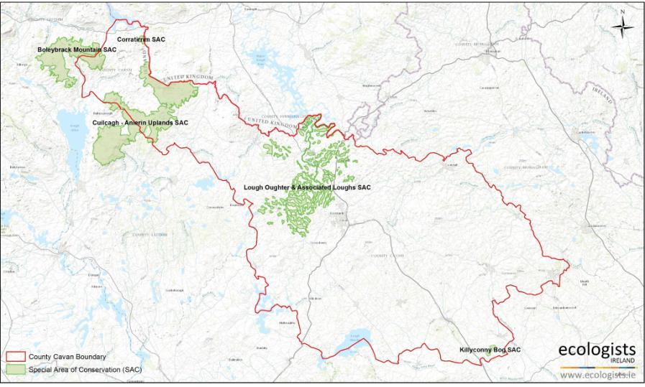
Figure 2. Special Areas of Conservation in Cavan County.

Table 2. Qualifying Features of Special Areas of Conservation in Cavan County.

NATURA 2000 Site | Qualifying Features | Extent and Character | Threats to Site Integrity
Boleybrack Mountain Special | Natural dystrophic lakes and ponds [3160] | This habitat represents approximately 1% of the land cover within the SAC (c.42ha). Natural dystrophic lakes occur in 87% of all suitable 10km squares in Ireland. 10 SACs are designated for this habitat type. Boleybrack Mountain SAC represents 1.17% of the total SAC contribution in the Member State. | It is considered that the adoption of this proposed Variation will not affect this Natura 2000 site. The proposed Variation will not diminish the effect of existing policies and objectives in the Cavan County Development Plan 2014-2020 which provide protection for water quality, protected habitats and protected species, including SAC’s and SPA’s from development which would detrimentally impact upon them.
Area of Conservation [002032] | Dystrophic systems most often associated with Blanket bogs
Site Area: 4268.76ha | [7130] and may include isolated seasonal pools, random
 | collections of irregularly-shaped more-or-less permanent
Boleybrack Mountain is an | waters, and ordered linear or concentric arrays of pools and
extensive upland plateau | small lochs. Dystrophic pools may be also found on raised |  | .
situated to the north of Lough | bogs situated mainly on plains and valley bottoms. These
Allen. It is dominated by blanket | water bodies are very acidic and poor in plant nutrients.
bog and wet heath, with small | Their water has a high humic acid content and is usually
oligotrophic lakes scattered | stained dark brown through exposure to peat. Most
throughout. | examples are small (less than 5 ha in extent), shallow, and
 | contain a limited range of flora and fauna.
 | Northern Atlantic wet heaths with Erica tetralix [4010] | This habitat represents 30% of the land
 | Wet heath usually occurs on acidic, nutrient-poor substrates, | cover within the SAC (c.1280ha). Wet
 | such as shallow peats or sandy soils with impeded drainage. | heath occurs in 89% of suitable 10km
 | The vegetation is typically dominated by mixtures of cross- | squares in Ireland. 40 SACs are
 | leaved heath Erica tetralix, heather Calluna vulgaris, | designated for this habitat type.
 | grasses, sedges and Sphagnum bog-mosses | Boleybrack Mountain SAC represents
 |  | 3.15% of the total SAC contribution for the
 |  | Member State.
 | European dry heaths [4030] | This habitat represents 22% of the land
 | Occur in a variety of forms in Ireland, mostly on free- | cover within the SAC (c.939ha). Dry
 | draining, nutrient poor acidic soils associated with upland or | Heaths occur in 81% of all suitable 10km
 | lowland slopes. | squares in Ireland. Boleybrack Mountain

represents c.2.4% of the total SAC
contribution within the Member State.
 | Molinia meadows on calcareous, peaty or clayey-silt- laden soils (Molinion caeruleae) [6410]  Molinion meadows are found mainly on moist, moderately base-rich, peats and peaty gley soils, often with fluctuating water tables. They usually occur as components of wet pastures or fens, and often form mosaics with dry grassland,  heath, mire and scrub communities. | This habitat represents 1% of the land cover within the SAC (c.42ha). Molinia meadows occur within 96% of all suitable 10km squares in Ireland. Boleybrack Mountain represents c.1.3% of the total SAC contribution within the Member State.
 | Blanket bogs (*if active only) [7130]  These extensive peatlands have formed in areas where there is a climate of high rainfall and a low level of evapotranspiration, allowing peat to develop not only in wet hollows but over large expanses of undulating ground.  *Active’ is defined as supporting a significant area of vegetation that is normally peat-forming. Typical species include the important peat-forming species, such as bog- mosses Sphagnum spp. and cottongrasses Eriophorum spp., or purple moor-grass Molinia caerulea in certain circumstances, together with heather Calluna vulgaris and  other ericaceous species. | This habitat represents 30% of the land cover within the SAC (c.1280ha). Blanket Bogs occurs in 83% of all suitable 10km squares in Ireland. Boleybrack Mountain represents c.0.8% of the total SAC contribution for this habitat in the Member State.
Killyconny Bog candidate Special Area of Conservation [000006]  Site Area: 191.2ha  There are few raised bogs in the | Active raised bogs [7110]  Peat-forming ecosystems that have developed during thousands of years of peat accumulation, to such an extent that the depth of peat isolates them from the influence of groundwater. Within the raised bog ecosystem the bog | The habitat type forms 20% of the land cover within the SAC (c.38.2ha). This habitat is largely confined to the lowland central and mid-west of the country and is extremely rare in Ireland with few pristine | It is considered that the adoption of this proposed Variation will not affect this Natura 2000 site. The proposed Variation will not diminish the effect of existing policies and objectives in the Cavan County Development Plan 2014-2020 which provide protection for water quality, protected habitats and protected species, including SAC’s and SPA’s from development which would detrimentally impact upon them.

region and Killyconny Bog is one of the best developed consisting of two small basins which have coalesced over a low drumlin ridge. | surface typically displays a distinctive micro-topography, with patterns of hummocks and hollows rich in Sphagnum and other peat-forming species. | examples remaining. This habitat has undergone an estimated decrease in land cover of more than 35% in the last decade and respectively only occurs in 56% of suitable concentrated 10km squares in Ireland. Killyconny Bog represents c.8.3% of the SAC contribution for this habitat in  the Member State.
 | Degraded raised bogs still capable of natural regeneration [7120] Degraded raised bogs occur where there has been widespread disruption, usually by man, to the structure and function of the peat body. This can involve changes to the hydrology, vegetation, and physical structure of the bog, leading to desiccation, oxidation and loss of species or changes in the balance of the species composition. In contrast to 7110 Active raised bogs, peat is not currently forming in degraded bog, however which are ‘capable of natural regeneration’, i.e. "where the hydrology can be repaired and where, with appropriate rehabilitation management, there is a reasonable expectation of re- establishing vegetation with peat-forming capability within 30  years". | This habitat type forms c.26% of the land cover within the SAC (49.7ha). This habitat occurs in 81% of 10km squares in Ireland, exemplifying the extent of degradation within raised bogs in a national context.  Killyconny bog represents c.0.6% of the SAC contribution for this habitat in the Member State.
Corratirrim Special Area of Conservation [000979]  Site Area: 117.03ha  In the north-west of Co. Cavan, | Limestone pavements [8240]  The landscape, flora and associated fauna have evolved in response to millennia of farming, principally grazing. This habitat supports a diverse flora and forms mosaics of orchid- | This habitat forms c.23% of the land cover within the SAC (23.4ha). Limestone pavement occur in 81% of suitable 10km squares in Ireland. 23 SACs are | It is considered that the adoption of this proposed Variation will not affect this Natura 2000 site. The proposed Variation will not diminish the effect of existing policies and objectives in the Cavan County Development Plan 2014-2020 which provide protection for water quality, protected habitats and protected species, including SAC’s and SPA’s from development which would detrimentally impact upon them.

Carboniferous limestone underlies the shales and grits that form the Cuilcagh range. | rich grassland, limestone heath and hazel scrub. Limestone pavement is found mainly in counties Clare, Galway and Mayo, most famously in the Burren and the Aran Islands. | designated for this habitat type. Corratirrim represents c.0.1% of the total SAC contribution for this habitat in the Member State.
Cuilcagh – Anierin Uplands Special Area of Conservation [000584]  Site Area: 9739.7ha  This site has one of the largest expanses of intact, undisturbed mountain blanket bog in Ireland. | Oligotrophic to mesotrophic standing waters with vegetation of the Littorelletea uniflorae and/or of the Isoeto-Nanojuncetea [3130] The clear soft water which characterises this habitat type contains low to moderate levels of plant nutrients and supports a characteristic assemblage of plant species. The vegetation community is characterised by amphibious short perennial vegetation, with shoreweed Littorella uniflora being considered as the defining component. | This habitat represents c.1% of the land cover with the SAC (97.4ha). Oligotrophic to Mesotrophic lakes occur in 83% of suitable 10km squares in Ireland. There are 10 SACs designated for this habitat type. Cuilcagh – Anierin Uplands represents c.2.4% of the SAC contribution for this habitat within the Member State. | It is considered that the adoption of this proposed Variation will not affect this Natura 2000 site. The proposed Variation will not diminish the effect of existing policies and objectives in the Cavan County Development Plan 2014-2020 which provide protection for water quality, protected habitats and protected species, including SAC’s and SPA’s from development which would detrimentally impact upon them.
 | Natural dystrophic lakes and ponds [3160] Dystrophic systems most often occur on 7130 Blanket bogs and may include isolated seasonal pools, random collections of irregularly-shaped more-or-less permanent waters, and ordered linear or concentric arrays of pools and small lochs. These water bodies are very acidic and poor in plant nutrients. Their water has a high humic acid content and is usually stained dark brown through exposure to peat. Most examples are small (less than 5 ha in extent), shallow, and contain a limited range of flora and fauna | This habitat represents approximately 1% of the land cover within the SAC (c.97ha). Natural dystrophic lakes occur in 87% of all suitable 10km squares in Ireland. 10 SACs are designated for this habitat type. Cuilcagh - Anierin Uplands SAC represents c.2.7% of the total SAC contribution in the Member State.

 | Northern Atlantic wet heaths with Erica tetralix [4010] | This habitat represents approximately 15% of the land cover within the SAC (c.1461ha), equivalent to 3.6% of the total  SAC contribution in the Member State.
 | European dry heaths [4030] | This habitat represents approximately 5% of the land cover within the SAC (c.487ha), equivalent to 1.25% of the total SAC  contribution in the Member State.
 | Species rich Nardus grasslands, on siliceous substrates in mountain areas [6230] Species-rich Nardus grasslands tend to develop where there is flushing through base-rich strata on siliceous bedrock. These may include moderately base-rich metamorphic and igneous rocks. The soils have an acidic pH (<7.0 and mainly <6.0) and are derived from bedrocks with at least some silica. Species-rich Nardus grasslands are important because they support a wide range of species, including Atlantic, sub-Atlantic and arctic-alpine plants and invertebrates. | This habitat represents approximately 1% of the land cover within the SAC (c.97.4ha). This habitat occurs in 84% of all suitable 10km squares in Ireland. 10 SACs are designated for this habitat type. Cuilcagh – Anierin represents 13.3% of the total SAC contribution for this habitat type in the Member State.
 | Blanket bogs (*if active only) [7130] | This habitat represents approximately 58% of the land cover within the SAC (c.5649ha), equivalent to c.3.6% of the total SAC contribution within the Member State.
 | Siliceous rocky slopes with chasmophytic vegetation  [8220] Chasmophytic vegetation consists of plant communities that colonise the cracks and fissures of rock | This habitat represents approximately 1%  of the land cover within the SAC (97.4ha) and occurs in 100% of suitable 10km

 | faces. The type of plant community that develops is largely determined by the base-status of the rock face. Siliceous communities develop on acid rocks whereas calcareous sub- types develop on lime-rich rocks such as limestone and  calcareous schists. | squares in Ireland. 16 SACs are designated for this habitat type. Cuilcagh – Anierin Uplands represent c.2.81% of the total SAC contribution within the Member  State.
Lough Oughter & Associated Loughs [000007]  Site Area: 4757.9ha Lough Oughter and its  associated loughs occupy much of the lowland drumlin belt  in north and central Cavan between Upper Lough Erne, Killashandra and Cavan town consisting of some 90 inter-drumlin lakes and 14  basins in the course of the Erne River. | Natural eutrophic lakes with Magnopotamion or Hydrocharition-type vegetation [3150] Natural eutrophic lakes have nutrient levels that are higher than those of oligotrophic, dystrophic or mesotrophic lakes, resulting in higher natural productivity, and are typically species-rich. However, many such lakes have been damaged by over- enrichment with nutrients, resulting in hypertrophic conditions and a reduction in species-richness. | This habitat represents approximately 67% of the land cover within the SAC (3187.8ha). This habitat occurs in 87% of suitable 10km squares in Ireland. 11 SACs are designated for this habitat type. Lough Oughter & Associated Loughs represent 24% of the total SAC contribution within the Member State. | It is considered that the adoption of this proposed Variation will not affect this Natura 2000 site. The proposed Variation will not diminish the effect of existing policies and objectives in the Cavan County Development Plan 2014-2020 which provide protection for water quality, protected habitats and protected species, including SAC’s and SPA’s from development which would detrimentally impact upon them.
River Boyne & River Blackwater Special Area of Conservation [002299]  Site Area: 2320.8ha | Alkaline Fens [7230]  Alkaline fens consist of a complex assemblage of vegetation types characteristic of sites where there is tufa and/or peat formation with a high water table and a calcareous base-rich | The extent and location of Alkaline Fen within the SAC is not detailed in the site synopsis. Alkaline Fen occurs in 73.9% of suitable 10km squares in Ireland. 39 SACs | It is considered that the adoption of this proposed Variation will not affect this Natura 2000 site. The proposed Variation will not diminish the effect of existing policies and objectives in the Cavan County Development Plan 2014-2020 which provide protection for water quality, protected habitats and protected species, including SAC’s and SPA’s from development which would detrimentally impact upon them.

 | water supply. | are designated for this habitat type. Within
 |  | the SAC this habitat represents only c.1%
 |  | of the land cover (23.2ha), equivalent to
 |  | 0.79% of the entire SAC contribution within
 |  | the Member State.
 | Alluvial forests with Alnus glutinosa and Fraxinus | The extent of alluvial forests within the
 | excelsior [91E0] | Boyne catchment is localised and
 | Alluvial forests with Alnus glutinosa and Fraxinus excelsior | restricted to small areas. The largest area
 | (Alno-Padion, Alnion incanae, Salicion albae) comprises | of this habitat occurs on a chain of three
 | woods dominated by alder Alnus glutinosa and willow Salix | small riparian islands 2.5km west of
 | spp. on flood plains in a range of situations from islands in | Drogheda. Alluvial Forest occurs in 61% of
 | river channels to low-lying wetlands alongside the channels. | suitable 10km squares in Ireland. 28 SACs
 | The habitat typically occurs on moderately base-rich, | are designated for this habitat type. Within
 | eutrophic soils subject to periodic inundation. | the SAC, however, this habitat represents
 |  | only c.1% of land cover (23.2ha),
 |  | equivalent to c.0.71% of the entire SAC
 |  | contribution within the Member State.
 | River Lamprey Lampetra fluviatilis [1099] | River Lamprey are widespread throughout
 | The river lamprey Lampetra fluviatilis is found in coastal | Ireland and considered to be in favourable
 | waters, estuaries and accessible rivers. The species is | conservation status nationally, occupying
 | normally anadromous (i.e. spawning in freshwater but | 100% of suitable 10km squares in Ireland.
 | completing part of its life cycle in the sea), and pollution or | 9 SACs are designated for River Lamprey.
 | artificial obstacles such as weirs or dams impede migration. | The River Boyne & River Blackwater
 |  | represents 1.12% of the total SAC
 |  | contribution for this species.
 | Atlantic Salmon Salmo salar [1106] | The River Boyne system is an important

 | The Atlantic salmon is an anadromous species (i.e. adults migrate from the sea to breed in freshwater). Spawning takes place in shallow excavations called redds, found in shallow gravelly areas in clean rivers and streams where the water flows swiftly. The young that emerge spread out into other parts of the river. After a period of 1-6 years the young salmon migrate downstream to the sea as ‘smolts’. Salmon have a homing instinct that draws them back to spawn in the river of their birth after 1-3 years in the sea. This behaviour has resulted in genetically distinct stock between rivers and even within individual rivers, with some evidence of further  genetic distinctiveness in the tributaries of large rivers. | spawning catchment for Atlantic Salmon, with excellent salmon spawning throughout the main tributaries and headwaters, Atlantic Salmon occur in 148 Irish Rivers. 26 SACs are designated for this species. The River Boyne & River Blackwater represents 0.52% of the total SAC contribution in the Member State.
 | European Otter Lutra lutra [1355]  The otter Lutra lutra is a semi-aquatic mammal, which occurs in a wide range of ecological conditions, including inland freshwater and coastal areas. Inland populations utilise a range of running and standing freshwaters. These must have an abundant supply of food (normally associated with high water quality), together with suitable habitat, such as vegetated river banks, islands, reedbeds and woodland, which are used for foraging, breeding and resting. | Occur throughout the Boyne river system. Nationally the European Otter occupies 53.8% of suitable 10km squares in Ireland. 47 SACs are designated for this species. The River Boyne & River Blackwater 0.34% of the total SAC contribution.

Special Protection Areas in Cavan County.
Many species of migratory waterbirds depend on interconnected networks of wetlands. The extensive inter- drumlin networks of wetlands of Cavan are an important resource for migrating and wintering waterbirds and three of the four Special Protection Areas in the County are designated for these interest features. Wetlands are also a great asset to the local community and economy, benefitting people by providing clean water and opportunities for fishing, agriculture, recreation and tourism within the County. Despite their importance, wetlands are amongst the world’s most vulnerable ecosystems – being threatened by conversion for agriculture and development, drought, drainage and pollution. Consequently, an alarming 42% of the migratory waterbird populations in Europe are in decline.

The remaining site is the River Boyne and River Blackwater SPA and is designated for Kingfisher. Figure 3 shows all SPAs in Cavan County. Table 3 summarise the qualifying features of each site and any potential threats from Variation No. 1 Cavan County Development Plan 2014 – 2020.

Figure 3. Special Protection Areas in Cavan County.
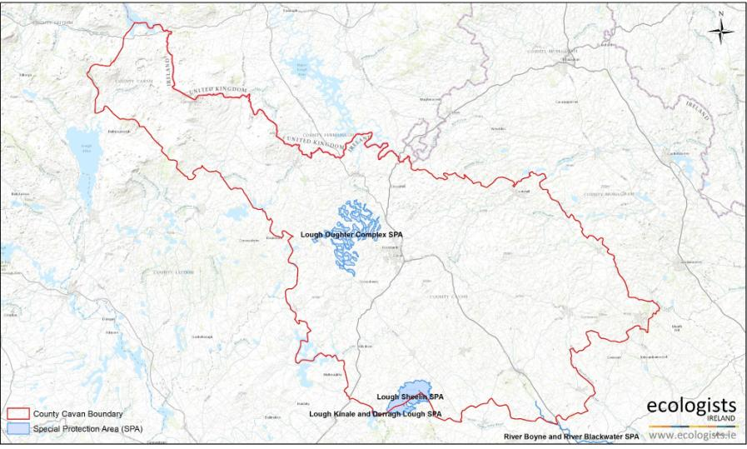

Table 3. Qualifying Features of Special Protection Areas in Cavan County.

NATURA 2000 Site | Qualifying Features | Extent and Character | Threats to Site Integrity
Lough Oughter Complex Special Protection Area [004049]  Site Area: 1466.5ha  The Lough Oughter Complex SPA is of ornithological importance for its wintering waterbird populations. Of particular note is the internationally important population of Whooper Swan that is based in the area. The site also supports nationally important populations of a further two wintering species and, notably, holds the highest breeding concentrations of Great Crested Grebe in the country. | Great Crested Grebe [A005] is a widespread breeder across much of Europe, which accounts for less than half of its global breeding range. Its European breeding population is large (>300,000 pairs). The species breeds on fresh or brackish waters with abundant emergent and submerged vegetation showing a preference for non-acidic eutrophic waterbodies with flat or sloping banks and muddy or sandy substrates usually 0.5-5 m deep and with large areas of open water. Suitable habitats include small pools or lakes, backwaters of slow- flowing rivers and artificial waterbodies (e.g. reservoirs, fish-ponds, gravel pits and ornamental lakes). | Ireland supports approximately 2,074 breeding pairs. It is estimated that c.24% of the breeding population in Ireland occurs within SPAs. Lough Oughter is at the centre of the Irish breeding range of Great Crested Grebe and the site supports in excess of 5.5% of the estimated national breeding total of this species (115 individuals), equivalent to 23% of the SPA contribution for this species respectively.  Ireland supports approximately 3,500 wintering Great Crested Grebe. It is estimated that c.43% occur in SPAs. Lough Oughter Complex support an average peak count of 85 individuals each year, equivalent to 2.4% of the wintering population in the Member State, and 6.5% of the SPA contribution for this species respectively. | It is considered that the adoption of this proposed Variation will not affect this Natura 2000 site. The proposed Variation will not diminish the effect of existing policies and objectives in the Cavan County Development Plan 2014-2020 which provide protection for water quality, protected habitats and protected species, including SAC’s and SPA’s from development which would detrimentally impact upon them.  .
 | Whooper Swan [A038] Four discrete populations of the Whooper Swan have been identified in western Eurasia.  Icelandic breeding stock winters in Iceland, Britain and Ireland comprising of c.16,000 birds. | Ireland supports approximately 10, 320 wintering Whooper Swan. It is estimated that c.1,853 of these birds winter in SPAs. Lough Oughter supports 318 roosting Whooper Swan (five year mean peak 1995 – 2000), equivalent to 3% of the wintering population in the Member State, and 17% of the SPA contribution for this species. The Icelandic population is believed to be stable or declining slightly.

 | Wigeon [A050]  In winter, Wigeon are highly gregarious, and occur in large, mobile flocks. Wigeon is largely a coastal species, feeding on mud-flats, coastal flooded grassland and saltmarsh pastures, however are also widespread on inland flooded grassland. | Ireland supports approximately 125,000 wintering Wigeon. It is estimated 3% (3,863) of wintering Wigeon occur within the SPA network. Lough Oughter Complex supports 903 (five year mean peak 1995 – 2000) Wigeon, equivalent to 0.7% of the wintering population within the Member State, and 23.3% of the total SPA contribution for this species.
 | Wetland & Waterbirds [A999] | The E.U. Birds Directive pays particular attention to wetlands and, as these form part of this SPA, the wetlands and its associated waterbirds are of special conservation interest for  Wetland & Waterbirds.
Lough Sheelin Special Protection Area [004065] Site Area: 1901.7ha  Lough Sheelin is a medium- to large-sized lake, with a maximum length of 7 km. The lake lies near the top of the catchment of the Inny River, a main tributary of the River Shannon. | Great Crested Grebe [A005]  As detailed above. | Ireland supports approximately 3,500 wintering Great Crested Grebe. It is estimated that c.43% occur in SPAs.  Approximately 140 Great crested grebe winter at Lough Sheelin, equivalent to 4% of the wintering population in the Member State, and 9.3% of the total SPA contribution for this  species. | It is considered that the adoption of this proposed Variation will not affect this Natura 2000 site. The proposed Variation will not diminish the effect of existing policies and objectives in the Cavan County Development Plan 2014-2020 which provide protection for water quality, protected habitats and protected species, including SAC’s and SPA’s from development which would detrimentally impact upon them.
 | Pochard [A059]  During the winter Pochard frequent similar habitats to those it breeds in, including large lakes slow-flowing rivers, reservoirs, brackish waters, marshes and flooded gravel pits. Pochard will shift to coastal habitats such as brackish lagoons, tidal estuaries and inshore waters. Pochard prefer waterbodies less | Ireland supports approximately 40,000, wintering Pochard. It is estimated that c.60% of these individuals occur in SPAs. 546 Pochard (average 5 year peak 1995 – 2000) winter at Lough Sheelin, equivalent to 1.3% of the wintering population in the Member State, and 2.2% of the total SPA contribution for this species.

than 3 m deep, diving to the bottom to forage. They feed on seeds, roots, grasses, sedges and aquatic plants, as well as invertebrates, amphibians and
small fish.
 | Tufted Duck [ A061]  In winter, Tufted Ducks are highly gregarious, preferring large, freshwater lakes, ponds and reservoirs, though they are also found in estuaries, along sheltered seacoasts and on brackish inland seas in winter. They feed by diving, with 80% of the diet consisting of animal material, but also feed on seeds and green parts of aquatic plants, aquatic insects and crustaceans. Its European wintering population is large (>1,200,000 individuals) | Ireland supports approximately 40,000 wintering Tufted Duck each winter. It is estimated that c.51% of the wintering population occurs within SPAs. Lough Sheelin supports an average peak number of 762 individuals, equivalent to 1.9% of the wintering population in the Member State, and 3.6% of the total SAC contribution for this species.
 | Goldeneye [A067] is a widespread breeder in northern and central Europe, which holds less than half of its global population. Its European wintering population is large (>310,000 individuals). | In Ireland the species winters mainly on large rivers, loughs, turloughs and reservoirs. The species is restricted to water close to the shore and less than 10 m deep (showing a preference for waters 4 m deep). Ireland supports approximately 11,000 individual Goldeneye each winter. It is estimated that c.77% of the wintering population occurs within SPAs. Lough Sheelin supports an average peak number of 225 individuals, equivalent to 2% of the wintering population

within the Member State, and 2.5%of the total SPA
contribution for this species.
 | Wetland & Waterbirds [A999] | As detailed above.
Lough Kinale Special Protection Area [004061] Site Area: 282.3ha  Lough Kinale is a relatively small lake that is situated immediately downstream of Lough Sheelin. Lough Kinale has two main basins, almost separated by swamp formations. | Pochard [A059]  As detailed above. | Ireland supports approximately 40,000, wintering Pochard. It is estimated that c.60% of these individuals occur in SPAs.  Lough Kinale supports a peak average number of 951 individuals, equivalent to 2.3% of the wintering population within the Member State, and 3.9% of the total SPA  contribution for this species. | It is considered that the adoption of this proposed Variation will not affect this Natura 2000 site. The proposed Variation will not diminish the effect of existing policies and objectives in the Cavan County Development Plan 2014-2020 which provide protection for water quality, protected habitats and protected species, including SAC’s and SPA’s from development which would detrimentally impact upon them.
 | Tufted Duck [ A061]  As detailed above. | Ireland supports approximately 40,000 wintering Tufted Duck each winter. It is estimated that c.51% of the wintering population occurs within SPAs. Lough Kinale supports a peak average number of 449 individuals, equivalent to 1.1% of the wintering population within the Member State, and 2.2% of the total SPA contribution for this species.
 | Wetland & Waterbirds [A999] | As detailed above.

River Boyne & River Blackwater Special Protection Area [004232]  Site Area: 460.3ha | Kingfisher Alcedo atthis  [breeding] [A229]  Kingfishers are relatively widespread throughout Ireland with a more easterly bias in their distribution, however are considered to be a bird of conservation concern (Amber listed). | The survey undertaken in 2010 by Cummins et al. 2010 estimated 15 probable and 4 possible breeding pairs within the River Boyne, representing some of the highest numbers per kilometre recorded during the survey (0.09 – 0.12 territories per km). Estimates of national population were not provided in Cummins et al. 2010 due to the site specific focus of the study. Gibbons et al. 1993 present estimates of between 1,300 – 2,100 breeding pairs in Ireland. The SPA therefore represents  between c.0.9 and 1.5% of the national population. | It is considered that the adoption of this proposed Variation will not affect this Natura 2000 site. The proposed Variation will not diminish the effect of existing policies and objectives in the Cavan County Development Plan 2014-2020 which provide protection for water quality, protected habitats and protected species, including SAC’s and SPA’s from development which would detrimentally impact upon them.

  - Overview of Natura Sites within 15km of Cavan County
All Natura 2000 sites entirely or partially within a 15km buffer from the county boundary have been included in this assessment in accordance with the Department of Environment, Heritage and Local Government guidance (DoEHLG, 2010). This distance was deemed to be sufficient to cover all likely significant effects which may arise from the implementation of Variation No. 1 County Development Plan on Natura 2000 sites. ArcView software using Ordnance Survey maps and NPWS shapefiles were used to identify the boundaries of Natura 2000 Sites within 15km of the Cavan County border. Cavan borders six counties; Leitrim to the west, Fermanagh and Monaghan to the north, Meath to the south-east, Longford to the south-west and Westmeath to the south.

Special Areas of Conservation within 15km of Cavan County
Eight SACs occur within 15km of the Cavan County boundary. Figure 4 shows the location of these sites in relation to Cavan County. Table 4 summarises the designated features of these sites and any potential impacts from policies and objectives in Variation No. 1 Cavan County Development Plan.

Figure 4. Special Areas of Conservation within 15km of Cavan County.
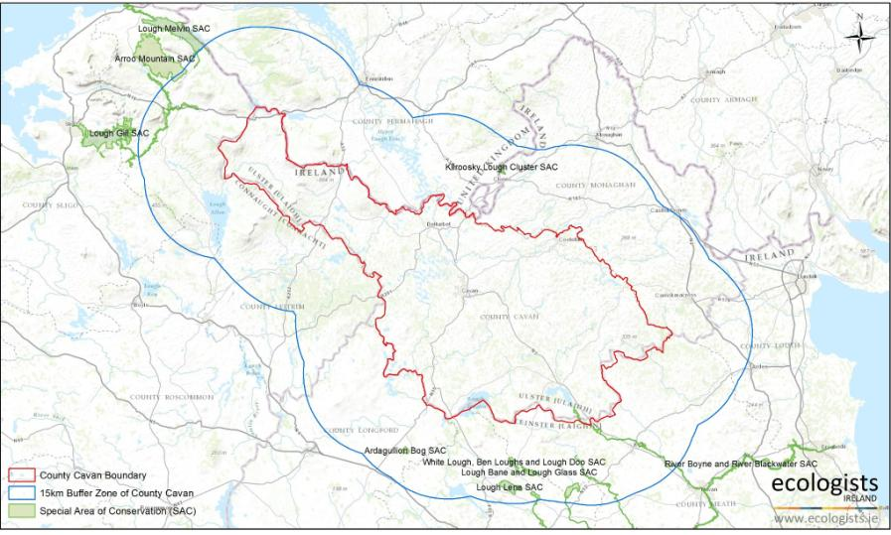

Table 4. Qualifying Features of Special Areas of Conservation within 15km of Cavan County.

NATURA 2000 Site | Qualifying Features | Threats to Site Integrity
Lough Melvin Special Area of Conservation [000428] Site Area: 2269.8ha | Oligotrophic to mesotrophic standing waters with vegetation of the Littorelletea uniflorae and Isoeto-Nanojuncetea [ 3130] | There are no current policies within Variation No. 1 Cavan County Development Plan that are considered to be potential threats to site integrity. This is due to the nature of the proposed Variation and the distance of any towns and villages in Cavan from the Natura 2000 site.
 | Atlantic Salmon Salmo salar [1106]
 | European Otter Lutra lutra [1355]
Aroo Mountain Special Area of Conservation [ 001403] Site Area: 3967.9ha | Blanket Bog (*active only) [7130] | There are no current policies within Variation No. 1 Cavan County Development Plan that are considered to be potential threats to site integrity. This is due to the nature of the proposed Variation and the distance of any towns and villages in Cavan from the Natura 2000 site
 | Northern Atlantic wet heaths with Erica tetralix [4010]
 | Calcareous rocky slopes with chasmophytic vegetation [8210]
 | Petrifying spring with tufa formation (Cratoneurion) [7220]
 | Calcareous and calschist screes of the montane to alpin levels [8120]
Lough Gill Special Area of Conservation [ 001976] Site Area: 3298.5ha | Natural eutrophic lakes with Magnopotamion or Hydrocharition-type vegetation [3150] | There are no current policies within Variation No. 1 Cavan County Development Plan that are considered to be potential threats to site integrity. This is due to the nature of the proposed Variation and the distance of any towns and villages in Cavan from the Natura 2000 site
 | Alluvial forests with Alnus-glutinosa and Fraxinus excelsior [91E0]

 | Old sessile oak woods with Ilex and Blechnum [91A0] | There are no current policies within Variation No. 1 Cavan County Development Plan that are considered to be potential threats to site integrity. This is due to the nature of the proposed Variation and the distance of any towns and villages in Cavan from the Natura 2000 site
 | Sea Lamprey Petromyzon marinus [1095]
Brook Lamprey Lampetra planeri [1096] / River Lamprey
Lampetra fluviatilis [1099]
 | Atlantic Salmon Salmo salar [1106]
 | European Otter Lutra lutra [1355]
 | White-clawed Crayfish Austropotamobius pallipes [1092]
Ardagullion Bog Candidate Special Area of Conservation [002341]  Site Area: 117.3ha  Ardaguillion Bog is located 5 km north-east of Edgeworthstown, mainly in the townlands of Cloonshannagh (Coolamber Manor Demesne) and Ardaguillon in Co. Longford. The site comprises a raised bog that includes both areas of high bog and cutover bog. | Active raised bogs [7110]. | There are no current policies within Variation No. 1 Cavan County Development Plan that are considered to be potential threats to site integrity. This is due to the nature of the proposed Variation and the distance of any towns and villages in Cavan from the Natura 2000 site
Degraded raised bogs still capable of natural regeneration
[7120].
Depressions on peat substrates of the Rhynchosporion
[7150].
Garriskil Bog Candidate Special Area of Conservation [000697]  Site Area: 324.8ha.  This raised bog site lies 3 km west of Lough Derravaragh and 3 km east of Rathowen. It is bounded to the southeast and southwest by the rivers Inny and Riffey. | Active raised bogs [7110]. | There are no current policies within Variation No. 1 Cavan County Development Plan that are considered to be potential threats to site integrity. This is due to the nature of the proposed Variation and the distance of any towns and villages in Cavan from the Natura 2000 site
 | Degraded raised bogs still capable of natural regeneration [7120].
Depressions on peat substrates of the Rhynchosporion
[7150].

Lough Lene Candidate Special Area of Conservation [002121]  Site Area: 489.9ha  This lake is situated 4km north east of Castlepollard in Co. Westmeath. It is a deep (20m max.), clear hard- water lake with marl deposition. | Hard oligo-mesotrophic waters with benthic vegetation of  Chara spp [3140]. | There are no current policies within Variation No. 1 Cavan County Development Plan that are considered to be potential threats to site integrity. This is due to the nature of the proposed Variation and the distance of any towns and villages in Cavan from the Natura 2000 site
 | White-clawed Crayfish Austropotamobius pallipes [1092].
White Lough, Ben Loughs & Lough Doo Candidate Special Area of Conservation [001810]  Site Area: 116.3ha.  This site is comprised of four hard water lakes in a small, poorly-drained valley, 4 km east of Castlepollard, Co. Westmeath. | Hard oligo-mesotrophic waters with benthic vegetation of  Chara spp [3140].
 | White-clawed Crayfish Austropotamobius pallipes [1092].
Lough Bane & Lough Glass Candidate Special Area of Conservation [002120]  Site Area: 203.5ha.  This site is located on the Meath/Westmeath border, about 10 km south of Oldcastle. It comprises three lakes situated in a shallow valley. Lough Bane is by far the largest of the group, with the much smaller Lough Glass occurring immediately to the east and Lough Glass North to the north-west. The lakes occur at the headwaters of the River Deel, with the main outflow at the south-east end of Lough Bane. | Hard oligo-mesotrophic waters with benthic vegetation of  Chara spp [3140].
 | White-clawed Crayfish Austropotamobius pallipes [1092].

Kilroosky Lough Cluster Special Area of Conservation [001786]  Site Area: 57.6ha.  Kilroosky Lough Cluster straddles the border with Northern Ireland, and is located approximately 2 km north-west of Clones, Co. Monaghan. The site consists of three separate areas which contain several calcium- rich, clean water (oligo-mesotrophic) lakes and their marginal fen vegetation. | Calcareous fens with Cladium mariscus and species of the  Caricion davallianae [7210].
Hard oligo-mesotrophic waters with benthic vegetation of
Chara spp [3140].
 | Alkaline Fens [7230].
 | White-clawed Crayfish Austropotamobius pallipes [1092].

  - Special Protection Areas within 15km of Cavan County
Two Special Protection Areas are designated within 15km of the Cavan county boundary. Both of these sites are located to the south of Cavan County in County Westmeath. Garriskil Bog SPA (14.1km south of the boundary) is designated for wintering Greenland white-fronted Goose, while Lough Derravaragh SPA (12.2km south of the boundary) is designated for its importance to wintering Waterbirds. Figure 5 shows the location of these SPAs in relation to Cavan County boundary. Table 5 summarises any potential impacts on these sites from policies and objectives within Variation No. 1 Cavan County Development Plan.

Figure 5. Special Protection Areas within 15km of Cavan County
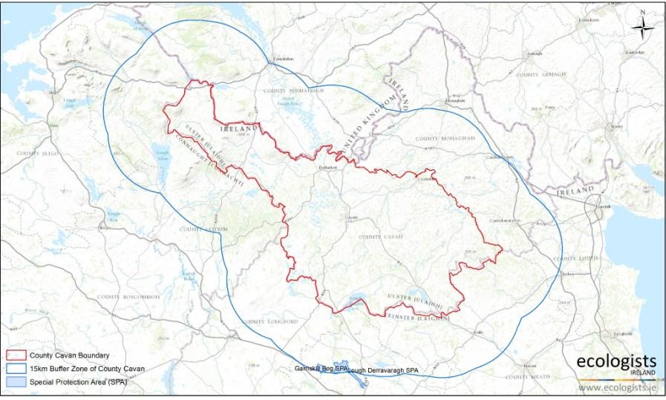

Table 5. Qualifying Features of Special Protection Areas within 15km of Cavan County.

NATURA 2000 Site | Qualifying Features | Threats to Site Integrity
Garriskil Bog Candidate Special Protection Area [004102]  Site Area: 324.25ha  Site lies 3 km west of Lough Derravaragh in Co. Westmeath. It is bounded to the southeast and southwest by the rivers Inny and Riffey. | Greenland White-fronted Goose [A395] | There are no current policies within Variation No. 1 Cavan County Development Plan that are considered to be potential threats to site integrity. This is due to the nature of the proposed Variation and the distance from the Natura 2000 site (14.1km).
Lough Derravaragh Special Protection Area [004043]  Site Area: 1120.4ha  Lough Derravaragh is located approximately 12 km north of Mullingar town. It is a medium- to large-sized lake of relatively shallow water (maximum depth 23 m). The lake extends along a south-east/north-west axis for approximately 8 km. The Inny River, a tributary of the River Shannon, is the main inflowing and outflowing river. | Whooper Swan [A038] | There are no current policies within Variation No. 1 Cavan County Development Plan that are considered to be potential threats to site integrity. This is due to the nature of the proposed Variation and the distance from the Natura 2000 site (12.2km).
 | Pochard [A059]
 | Tufted Duck [ A061]
 | Coot [ A125]
 | Wetland & Waterbirds [A999]

Conservation Objectives
To maintain the annexed habitats and species for which the Natura 2000 sites have been designated at a favourable conservation status. The maintenance of habitats and species within Natura 2000 sites at favourable conservation condition will contribute to the overall maintenance of favourable conservation status of those habitats and species at a national level. The favourable conservation status of a habitat is achieved when:
    - its natural range, and area it covers within that range, are stable or increasing;
    - the specific structure and functions which are necessary for its long-term maintenance exist and are likely to continue to exist for the foreseeable future; and,
    - the conservation status of its typical species is favourable;

The favourable conservation status of a species is achieved when:
    - population dynamics data on the species concerned indicate that it is maintaining itself on a long-term basis as a viable component of its natural habitats;
    - the natural range of the species is neither being reduced nor is likely to be reduced for the foreseeable future; and,
    - there is, and will probably continue to be, a sufficiently large habitat to maintain its populations on a long-term basis.

SCREENING OF POTENTIAL LIKELY SIGNIFICANT EFFECTS

Assessment Criteria
    - Description of the Elements of the Project likely to give rise to Impacts on Natura 2000 sites.
Describe the individual elements of the project (either alone or in combination with other plans or projects) likely to give rise to impacts on the Natura 2000 site.

The adopted Cavan County Development Plan 2014 – 2020 is a robust strategic document developed in combination with a range of European, National and Regional legislation; and, planning guidelines and policy documents pertinent to environmental management. The plan was guided by, and operates within the context of the National Plans and Guidance documents, notably the Border Regional Authority Regional Planning Guidelines 2010 – 2022 and Planning and Development (Amendment) Act 2010.

The County Development Plan has been subject to a Strategic Environmental Screening Report and Assessment, and is consistent with the Habitats Directive, following Appropriate Assessment Screening during its preparation.
There are no elements within the proposed Variation that give rise to impacts on the European sites considered in this screening assessment.

    - Description of the Likely Impact of the Plan on the Natura 2000 sites.
Describe any likely direct, indirect or secondary impacts of the Plan (either alone or in combination with other plans or projects) on the Natura 2000 site by virtue of:

Size, scale, area and land take:
The total area of land cover subject to land use zoning objectives in the exisitng Cavan County Development Plan 2014 – 2020 is 175ha. These lands areas are allocated to meet the projected demand for residential development as part of town and village plans on the basis of trends in population growth. The propsoped Variation does not alter this but seeks to actively promote the development of vacant sites that are in need of regeneration or in need of residential development within this allocation.

Distance from Natura 2000 site or key features of the site:
The Variation is policy only and does not contain objectives or actions that influence other plans or projects that may potentially impact on European Sites. The policies are actively seeking for lands currently zoned as residential to be used as residential and for lands that are in need of regeneration that are zoned to be utilised as per their zoning objective, in the existing plan.

Resource Requirement
The Variation does not relate to a specific project or development where resource requirements are quantifiable. The Variation does not have the potential to influence any other plans or projects in a manner that could potentially impact on European Sites as a result of resource requirement.

Emission (disposal to land, water or air):
The proposed Variation does not involve any emissions. Neither does it have the potential to influence any other plans or projects in a manner that could potentially impact on European sites as a result of emissions.
Duration:
The Cavan County Development Plan runs from 2014-2020. However, no potential for impacts on European Sites have been identified as a result of the plan or proposed Variation and therefore no impacts are anticipated as a result of the duration of the varied plan.

    - Description of Likely Changes to the Natura 2000 sites.
Describe any likely changes to the designated sites arising as result of:
      - Reduction of habitat area
Variation No. 1 does not propose any additional land take within Natura 2000 sites. Prior to any proposed plans or projects commencing, relevant ones shall be subject to an Appropriate Assessment in accordance with the requirements of Article 6(3) of the EU Habitats Directive (Directive 92/43/EEC).

      - Disturbance to key species
No specific plans or proposals in Variation No. 1 are considered to represent any significant impacts to key species through disturbance.

      - Habitat or species fragmentation
No specific plans or proposals in Variation No. 1 are considered to represent any significant impacts to habitat or species through fragmentation.

- Reduction in species density
No specific plans or proposals in Variation No. 1 are considered to represent any decline to species distribution or abundance within Natura 2000 sites.

- Changes in key indicators of conservation value (e.g., water-quality, etc.).
For the 2nd Planning Cycle of the Water Framework Directive, the Eastern, South Eastern, South Western, Western and Shannon River Basin Districts were merged to form one National River Basin District which is broken down into 46 catchment units. The main aims of the new River Basin Management Plan 2018-2021 is preventing the deterioration of water bodies, and achieving high status water body objectives. In conjunction with the new plan Cavan County Council is involved in the implementation and delivery of supporting measures in order to achieve these targets and Variation No. 1 does not alter this.

    - The Likely Impacts on the Natura 2000 sites as a whole.
Describe any likely impacts on the Natura 2000 as a whole in terms of:
      - Interference with the key relationships that define the structure of the site.
Variation No. 1 does not propose any development, plan or projects within any specific Natura 2000 site and therefore it is considered that there will be no potential negative impacts on the relationships that define the structure of Natura 2000 sites.

      - Interference with key relationships that define the function of the site.
Variation No. 1 does not propose any development, plan or projects within any specific Natura 2000 site and therefore it is considered that there will be no potential impacts on the relationships that define the structure of Natura 2000 sites.

    - Indicators of Significance of the Impacts.
Provide indicators of significance as a result of the identification of effects set out above in terms of:
      - Loss
There will be no loss of natural habitat within any Europeansite as a result of the proposped Variation.
      - Fragmentation
There will be no habitat fragmentation within any European site as a result of the proposed Vairation.
      - Disruption
There wll be no significant disruption to processes within any European site as a result of the propsoped Variation.
      - Disturbance
There will be no significant disturbance to fauna withn an European site as a result of the proposed Varuation.
      - Change to key elements of the site (e.g., water quality etc.)
Ther will be no changes to key elem,nts within any European site as a result of the proposed Variation.

    - Likely Significance of Potential Impacts
Describe from above those elements of the project or plan, or combination of elements, where the above potential impacts are likely to be significant or where the scale of magnitude of impacts are not known:
The screening process identified any impacts and relevant significance indicators of Variation No. 1 Cavan County Development Plan 2014 – 2020. A significant weighting on the conclusions of no significant impacts is based on the following rationale:
That in implementation of the Plan and the proposed Variation of the Plan, no areas of habitat that are important for the survival of the designated habitats or species within the Natura 2000 will be:
      - Modified or fragmented, destroyed or isolated. No key biogeochemical processes necessary for the survival of the designated features will be impacted, directly or indirectly or in the short to long term.
No ecologically meaningful proportion of habitat, or designated feature dependant on that habitat within the Natura 2000 sites examined in this screening will be:
      - Seriously impacted (either through loss, damage or deterioration in water quality).

Policies and Objectives protecting Natura 2000 sites
A material consideration in defining the strategy and policies of the existing Cavan County Development Plan 2014 – 2020 is the regulatory and legal instruments protecting designated sites and their respective conservation objectives. The Plan contains numerous policies and measures which contribute to the conservation objectives of Natura 2000 sites and compliment Cavan County Council’s obligation to ensure that the Plan complies with the requirements of the Habitats Directive.

The existing plan contains a number of policies and objectives that protect Natura 2000 sites and the environmental conditions that underpin these sites in accordance with the Habitats Directive. The Plan states;
It is the policy of Cavan County Council:
EI-O2 Carefully examine applications for extractive industries in areas designated as SACs, SPAs, pNHAs and other local designations.
RT OBJ 32 To implement the Roads Programme for the County in association with the NRA. Various road schemes will be subject to Environmental Impact Assessment and Appropriate Assessment, where necessary.
NHPOL6 To have regard to the views of the National Parks and Wildlife Service in respect of proposed development where such development may have an impact on a designated National or European site or proposed site for designation.
NHPOL7 To continue to undertake surveys and collect data that will assist Cavan County Council in building its knowledge base and meeting its obligations under Article 6 of the Habitat Directives.
Objectives:

It is an objective of Cavan County Council to:

NHOBJ3 To ensure an Appropriate Assessment in accordance with Article 6(3) and Article 6(4) of the Habitats Directive, and in accordance with the Department of the Environment, Heritage and Local Government Appropriate Assessment of Plans and Projects in Ireland – Guidance for Planning Authorities, 2009 and relevant EPA and European Commission guidance documents, is carried out in respect of any Plan or Project not directly connected with or necessary to the management of the site but likely to have significant effect on a Natura 2000 site(s), either individually or in combination with other plans or projects, in view of the site’s conservation objectives.

NHOBJ4 To protect and conserve the conservation value of Special Protection Areas, Special Areas of Conservation, Natural Heritage Areas and proposed Natural Heritage Areas as identified by the Minister for Arts, Heritage and the Gaeltacht and any other sites that may be proposed for designation during the lifetime of this plan.

Ecological Coherence of the Natura 2000 Network in Cavan County

In addition to examining Natura 2000 sites, Natural Heritage Areas (NHAs) and proposed Natural Heritage Areas (pNHAs) are also a material consideration in the screening process. A Natural Heritage Area is an area considered important for the habitats present or which holds species of plants and animals whose habitat needs protection. NHAs are given legal protection through statutory instruments which restrict certain activities that may impact negatively on the features of interest. Proposed Natural Heritage Areas are areas consisting of feature(s) of conservation interest but have not yet received full statutorily designation. Protecting other designated sites of conservation importance serves an important supportive and functional role; retaining ecological coherence in the wider landscape and improving ecosystem health, and, crucially supports the conservation objectives of the Natura 2000 network.

In addition to statutory instruments for NHAs, there is also a key legislative provision in the European Communities (Bird and Habitat) Regulations 2011 that aims to protect annexed habitats that occur outside Special Areas of Conservation. Habitats that are equivalent to those listed, but not within SACs are still classed as priority habitats of international and national importance and under Article 27 (4(b)), the planning authority has a duty to avoid the pollution or deterioration of Annex I habitats.

There are two Natural Heritage Areas in Cavan County, Slieve Rushen Bog NHA, which consists of a plateau of upland blanket bog straddling the border with Co. Fermanagh and is an important site for a declining population of breeding Hen harrier and a very small isolated population of Red Grouse; and, Lough Kinale which is also designated as a Special Protection Area, for its importance in supporting large numbers of wintering Waterbirds.

There are twenty proposed Natural Heritage areas in Cavan and represent a very diverse range of habitats and species of conservation importance. Of relevance to the ecological coherence of the Natura 2000 network will be that more than half of the pNHAs are inter-drumlin lakes and wetlands with a high variance in water chemistry (nutrient levels and pH), size, depth; in the development of fringe communities and the intact/modified vegetation sequences from open water to adjacent terrestrial habitats. Five pNHAs also closely overlap the boundaries of existing SACs.

Figure 6. Ecological Network Supporting Natura 2000 Sites in Cavan County.

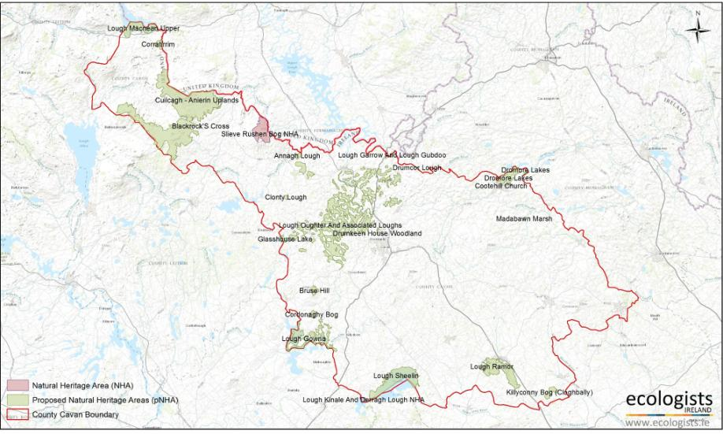

46

  - Policies & Objectives Protecting the Ecological Coherence of Natura 2000 sites. Article 10 of the Habitats Directive states that Member States shall endeavor in their land use, planning and development policies, to encourage the management of features of the landscape which are of importance for wild flora and fauna.

It is a policy of Cavan County Council:
- To conserve the existing wide range of flora, fauna and wildlife habitats in the county through the preservation of ecological corridors and networks vital to the migration, dispersal and genetic exchange of wild species.
- To designate County Biodiversity Sites within the lifetime of this plan and to protect the ecological integrity of these sites.

It is an objective of Cavan County Council:
- To implement the actions of Cavan County Biodiversity Plan and revisions thereof in fulfillment of the requirements of the National Biodiversity Plan.
- To continue to map the habitat of the county to enable planning for the future development in a sensitive and sustainable manner and this mapping to inform the development management process.

It is the policy of Cavan County Council:
EI –P1 To conserve and protect the environment, including in particular, the archaeological and natural heritage, areas of geological or geomorphic interest and conservation and protection of European Designated Sites and any other sites which are protected.
NH POL3 To ensure the protection of species of flora and fauna afforded legal protection under Irish and European Legislation.
NHPOL4 To assess the impact on biodiversity of proposals for large developments, particularly those on greenfield sites, or in environmentally sensitive areas. Any such developments where they do occur must include measures for enhancement of biodiversity.
NHPOL5 Development on or adjacent to National or European designated sites or proposed designated sites during the lifetime of this plan will be permitted only where an assessment has being carried out to the satisfaction of Cavan County Council, in consultation with National Parks and Wildlife Service and indicates that the overall integrity of the site will not be compromised or adversely affected.
WPP1 To protect the water resources of Cavan County.

WPP2 To protect the rivers streams and lakes and all watercourses in the County in order to promote sustainable and suitable habitats for flora and fauna.
WPP3 To promote the engagement of developers and regulators in the promotion of sustainable development and to encourage a high standard of environmental protection. The ‘precautionary principle’ will apply where a significant risk to the environment exists.
WPP4 To achieve good status in all our waterbodies and prevent the deterioration of existing quality status in all waterbodies in accordance with the requirements of the Water Framework Directive (WFD).
WLPOL1 To protect existing wetlands from destruction, infilling, fragmentation and degradation.

WTHSPOL4 To promote and encourage planting of native hedgerow species of local provenance.

IWW-P2 To protect the biodiversity of rivers, streams and other water courses and maintain them in an open state and to discourage the culverting or realignment thereof.
IWW-P5 To ensure that the County’s watercourses are retained for their biodiversity and flood protection values and to conserve and enhance, where possible the wildlife habitats of the county’s rivers and riparian zones, lakes, canals and streams which occur outside of designated areas to provide for a network of habitats and biodiversity corridors throughout the county,

Objectives:

It is an objective of Cavan County Council to:

TE&HBEA-O2 To promote the diversification of the rural economy and the growth of rural indigenous industry such as farming, forestry, tourism, while safeguarding the environment and role of the rural area as a strategic asset.
TE&HBEA-O5 To consider development in rural areas which present substantial employment opportunities having due regard to…[..] Full assessment of any potential environmental effects.
EI-O3 The Council will require that extractive industry proposals do not adversely impact upon the water environment, including surface water and groundwater quality and quantity, river corridors and associated wetlands.
WPO 1 All applications for development are assessed in terms of the potential impact on the quality of surface waters through the implementation of where applicable the RBMP’s objectives and targets set under the following:- Neagh Bann International River Basin District: Water Matters; North Western International River Basin District: Water Matters; Shannon International River Basin District: Water Matters and the Eastern International River Basin District: Water Matters.
WPO 2 All development applications are assessed in compliance with the European Communities Environmental Objectives on (Surface Waters) Regulations (2009) (S.I.No 272 of 2009) and the European Communities Environmental Objectives Groundwater Regulations 2010 (S.I. No. 9 of 2010).

F-O4 To resist forestry proposals which would unduly impact on protected views, sensitive upland areas, lands of wildlife interest and in the upper reaches of salmonid rivers which would affect biodiversity.
ENO13 The following issues will be considered in the assessment of a wind energy development:

Impact of the development on habitats, by direct loss, degradation, fragmentation and impact on habitats outside the site.
Impact of the development on birds through disturbance during construction and operation phase, collision mortality, barrier to movement and loss or degradation of habitats.
RHO16 To permit infill development, where appropriate, subject to good planning practice in matters of location, siting, design, access, wastewater disposal and the protection of environmentally sensitive areas and areas of high landscape value.
RHO19 To ensure that applications that are likely to have a significant effect on a Natura 2000 either directly or indirectly site are subject to an appropriate assessment in accordance with Article 6 of the Habitats Directive.
RHO24 All proposals involving the installation of an on-site wastewater treatment system must be in accordance with the requirements of the EPA Code of Practice Wastewater Treatment and Disposal Systems Serving Single Houses (2009) or any subsequent Code of Practice which supersedes it.
RT OBJ 29 To have regard to the Cavan County Local Biodiversity Action Plan 2009-2014 in the provision of any new Council roads.
WLOBJ1 To resist development that would destroy, fragment and degrade wetlands.

As detailed above Variation No. 1 Cavan County Development Plan 2014 – 2020 has many amendments within policies and objectives that serve to pre-emptively avoid and minimise risks to Natura 2000 sites. Many of these policies and objectives reinforce the statutory authorities’ obligation to comply with environmental legislation and serve to promote the importance of other areas designated for conservation interest and strengthen the protection of ecologically importance networks within the County.

5.0 CONCLUSIONS
This Stage 1: Screening for Appropriate Assessment of Variation No. 1 Cavan County Development Plan 2014 – 2020 has been conducted in accordance with the “Methodological guidance on the provisions of Article 6(3) and (4) of the Habitats Directive 92/43/EEC” as published by the European Commission and “Appropriate Assessment of Plans and Projects in Ireland: Guidance for Planning Authorities” published by the Department of Environment, Heritage and Local Government. It is objectively concluded that there are likely to be no significant effects on the Natura 2000 sites and that appropriate protection and mitigation, where necessary, in respect of Natura 2000 Network included within the existing plan and that the proposed Variation of the Plan has not undermined these policies and objectives and does not result in negative potential impacts on Natura 2000 sites.

STAGE 1 SCREENING FOR APPROPRIATE ASSESSMENT

FINDING OF NO SIGNIFICANT EFFECTS REPORT MATRIX (FONSE)

In accordance with Article 6(3) and 6(4) of the Habitats Directive 92/43/EEC

Development Type | Variation No 1 Cavan County Development Plan 2014 - 2020
Development Location | Cavan County including surrounding lands within 15km of the county boundary.
Natura 2000 site(s) within impact zone | Boleybrack Mountain Special Area of Conservation [002032]
 | Cuilcagh - Anierin Uplands Special Area of Conservation [000584]
 | Lough Oughter & Associated Loughs [000007]
 | River Boyne & River Blackwater Special Area of Conservation [002299]
 | Lough Oughter Special Protection Area [004049]
 | Lough Sheelin Special Protection Area [004065]
 | Lough Kinale Special Protection Area [004061]
 | River Boyne & River Blackwater Special Protection Area [004232]
 | Lough Melvin Special Area of Conservation [000428]
 | Aroo Mountain Special Area of Conservation [001403]
 | Lough Gill Special Area of Conservation [ 001976]
 | Ardagullion Bog Candidate Special Area of Conservation [00234]
 | Lough Lene Candidate Special Area of Conservation [002121]
 | White Lough, Ben Loughs & Lough Doo Candidate Special Area of Conservation [001810]
Lough Bane & Lough Glass Candidate Special Area of Conservation [002120]
Kilroosky Lough Cluster Special Area of
Conservation [001786]

Garriskill Bog Candidate Special Protection Area [004102]

Lough Derravaragh Special Protection Area [004043]
Qualifying interests of Natura 2000 site(s) | Natural dystrophic lakes and ponds [3160]  Northern Atlantic wet heaths with Erica tetralix  [4010]  European dry heaths [4030]  Molinia meadows on calcareous, peaty or clayey- silt-laden soils (Molinion caeruleae) [6410]  Blanket bogs (*if active only) [7130] Active raised bogs [7110]  Degraded raised bogs still capable of natural regeneration [7120]  Limestone pavements [8240]  Natural dystrophic lakes and ponds [3160]  Species rich Nardus grasslands, on siliceous substrates in mountain areas [6230]  Siliceous rocky slopes with chasmophytic vegetation [8220]  Alkaline Fens [7230]  Alluvial forests with Alnus glutinosa and Fraxinus excelsior [91E0]  Oligotrophic to mesotrophic standing waters with vegetation of the Littorelletea uniflorae and lsoeto-Nanojuncetea [ 3130]  Petrifying spring with tufa formation (Cratoneurion) [7220]  Calcareous and calschist screes of the montane to alpine levels [8120]  Natural eutrophic lakes with Magnopotamion or  Hydrocharition-type vegetation [3150]  Old sessile oak woods with llex and Blechnum  [91A0]  Depressions on peat substrates of the  Rhynchosporion [7150].  Hard oligo-mesotrophic waters with benthic vegetation of Chara spp [3140].  Calcareous fens with Cladium mariscus and species of the Caricion davallianae [7210].  Sea Lamprey [1095]  Brook Lamprey [1096]  River Lamprey [1099]  Atlantic Salmon [1106]

European Otter [1355]
White-clawed Crayfish [1092]

Wetland & Waterbirds [A999] Great Crested Grebe [A005] Whooper Swan [A038] Wigeon [A050]
Pochard [A059] Tufted Duck [ A061] Goldeneye [A067] Kingfisher [A229]
Greenland White-fronted Goose [A395]
Coot [ A125]

1.0 Name of project or plan: Variation No. 1 Cavan County Development Plan 2014 - 2020
Name and location of Natura 2000 site: | Variation No. 1 Cavan County Development Plan does not relate to any one Natura 2000 site and considers all sites within Cavan County and within a recommended 15km buffer zone.
Description of the project or plan | The Variation Seeks in accordance with the Urban Regeneration and Housing Act 2015 to integrate specific objectives which will identify and encourage the development and renewal of identified areas in need of regeneration or residential development and to specify the areas identified in need of regeneration or residential development
Is the project or plan directly connected with or necessary to the management of the site (provide details)? | Variation No. 1 Cavan County Development Plan 2014 - 2020 is not directly connected with or necessary to the management of the Natura 2000 Network.
Are there other projects or plans that together with the project or plan being assessed could affect the site (provide details)? | No, the propsoped Variation will have no significant residual impacts on any European site. therefore, the cululative impacts are not anticipated.

The assessment of significance of effects
Describe how the project or plan (alone or in combination) is likely to affect the Natura 2000 Site. | There will be no adverse effect on any European site as a result of the propsoped Variation.
Explain why these effects are not considered significant. | There will be no negative direct or indirect impacts or reduction in Annex I habitat within any European Site.  There will be no reduction in key habitats supporting populations of Annex I bbird species and no reduction in the populations of Annex I species.  There will be no reduction in key habitats supporting populations of Annex II species and no reduction in the popultios of any Annex II species.  Individual projects will be subject to Appropriate Assessment process as necessary.
List of agencies consulted: provide contact name and telephone or email address | Review of Stage 1 Screening for Appropriaute Assessment for Cavan Cpounty Development Plan 2014-2020  Review of Stage 1 Screeening for Appropeiate Assessment for Cavan Town and Environs Development Plan 2014-2020
Heritage Officer
Anne-Marie Ward (Cavan Heritage Officer) amcurley@cavancoco.ie

It can be objectively concluded that there are not likely to be significant effects on the Natura 2000
site(s) arising from Variation No. 1 Cavan County Development Plan 2014 - 2020.
The screening process identified all impacts and relevant significance indicators of Variation No. 1 Cavan County Development Plan 2014 - 2020.

No areas of habitat that are important for the survival of the designated features/species within the Natura 2000 sites will be:

- Modified or fragmented, destroyed or isolated. No key biogeochemical processes necessary for the survival of the designated features will be impacted, directly or indirectly or in the short to long term.

No ecologically meaningful proportion of the habitat of designated feature of the Natura 2000 sites will be:
- Seriously impacted (either through loss, damage or deterioration in water quality).
Overall Conclusions

