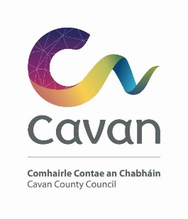

Cavan County Council

Cavan Belturbet Municipal District

09 April 2025

To Cathaoirleach and Each Member of The Cavan Belturbet Municipal District

Dear Councillor,
The next meeting of Cavan Belturbet Municipal District will be held in the Council Chamber, Courthouse, Cavan -
- On Tuesday 15th April at 10.00 AM.
.

The agenda is overleaf.

Yours sincerely

__________________
Meetings Administrator

A G E N D A/ CLÁR
- Confirmation of Minutes

To confirm Minutes of Monthly Meeting held on the 21.02.25

- Disclosure of Interests (Section 177 Local Government Act 2001)

- Correspondence- Email from TII.
Business prescribed by Statute, Standing Orders or Resolutions of the Council

- Executive Items-

Municipal Discretionary Grants 2025 for Cavan/ Belturbet MD.

- Road Works Programme update Paul Mulligan

Members Items

- That safety measures be implemented at the Junction of the N16 & Florencecourt Road in Blacklion.
Cllr Feeley
- To seek an update from Waterways Ireland on the development of plans to extend the Shannon Navigation north of Lough Allen towards Dowra and that we seek a meeting, in conjunction with Leitrim County Council with Waterways Ireland to discuss the matter. Cllr Feeley

- Junction signage in Cavan town. Cllr Smith

- Statue and area at Aghalane Bridge Cllr Smith

- That we ask the council to look at our roads verges that are totally dangerous.
And several accidents have occurred with absolutely no protection for road users especially the Drumalee road (R197) also speed on this road & the L1504 in Milltown
Cllr Fay

- That we look at the median and crosswalk at turn in of Furnaceland
in Swanlinbar.
4/5 businesses with oversized trucks cannot make the turn. And some have capsized and have had serious cost to their business. Cllr Fay

- Unruly teenage behaviour at Con Smith playground. Cllr N Brady

- Footpaths at Railway Road, Cavan Cllr Walsh

- People without phones since Storm Éowyn. Cllr Walsh

Date of next meeting.

AOB.

