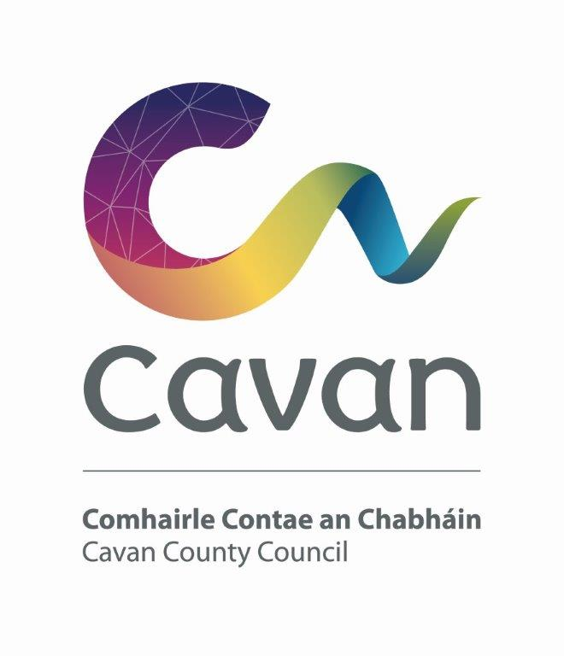

Cavan County Council

Cavan - Belturbet Municipal District

Minutes of Meeting held on Monday 26 February 2024.

Presiding: Councillor (Cllr) Áine Smith, Cathaoirleach

Present: Councillors John Paul Feeley, Brendan Fay, Peter McVitty, Madeleine Argue and Patricia Walsh

In attendance: Paul Mulligan, SEE, Cavan Belturbet Municipal District Office
Brendan Jennings, Director of Services, Cavan County Council

Also in attendance:
John Donohoe, Senior Executive Officer.
Deirdre Fitzpatrick, Administrative Officer.
Rosaleen Higgins, Assistant Staff Officer, Minute Taker.

A G E N D A/ CLÁR
- Confirmation of Minutes

To confirm Minutes of Monthly Meeting held on Monday 22nd January.
- Disclosure of Interests (Section 177 Local Government Act 2001)

Business prescribed by Statute, Standing Orders or Resolutions of the Council

- Confirmation of Minutes
Cllr Mc Vitty proposed minutes of last meetings and Cllr Walsh seconded.

Cllr Smith welcomed everyone to the meeting in Irish and the meeting proceeded.

Executive items

DRAFT LOCAL ECONOMIC AND COMMUNITY PLAN 2024-2029
- Consider for adoption a statement on the Draft Local Economic and Community Plan 2024-2029’s consistency with the core strategy and objectives of the Cavan County Development Plan 2022-2028

Mr Donohoe gave a brief overview of the draft economic and community plan 2024-2029 and said we were nearly at the end of the process. It went through numerous consultations. Mr Donohoe referenced Senior planner Mr Nicholas O Kanes letter which stated the following.

“I am satisfied that the LECP’s high-level goals, objectives, and actions along with the desired outcomes are all complementary to the policy framework contained in the adopted County Development Plan 2022- 2028. I am equally satisfied that the draft Local Economic & Community Plan 2024-2029 is consistent throughout with the Core Strategy and objectives of the adopted County Development Plan 2022-2028 and of the policy framework of the Northern and Western Regional Assembly Regional Spatial & Economic Strategy (2020-2032). This consistency is required in accordance with the requirements of section 66B(4) of the Local Government Act 2001, as amended.”

Finally, Mr Donohoe stated that the final draft is ready to go and will be proposed at the next full meeting of the council in March.

Road’s programme

Mr Mulligan presented his engineers report. He referenced the photo on front of the report, the works at Swellan Lwr and the new crash barrier. Some more landscaping needs to be done.

He spoke about the drainage ongoing at Killymoriarty. He acknowledged all the reps he got from Councillors and the public to get the job done. He proposed to finish it off in the 2024 Programme of works. He stated the residents will not know themselves when it is completed.

He commented on the side filling of the Corradeverrid, Dowra Road. Timber posts were driven along the verge to support the clay on side of the road. Steel mesh and Polythene were fixed to the timber posts.

He referenced the Derrymore patching, and drainage works job completed and the excellent job the lads done and also on the Yellow Road.

He commented to the Councillors that they may have noticed inlets opened on the N3 Cavan Bypass. This is to get the water of the road.

Mr Mulligan commented on the Safety Scheme at Milltown completed. Road markings, signage and public lighting were erected.

He spoke about the concrete works at St Phelim’s Place Cavan and the lovely job completed.

He complimented the new car park, pedestrian crossing and footpath for the Astro pitch in Cavan Town.

Cllr Walsh asked could stewards direct traffic down to carpark.

Mr Jennings said a lot of work has been done and loads of space now for parking. If the clubs do not comply, and park in the carpark, we will have to put a steward in place, and they will have to pay for it.

Cllr Smith thanked Paul for his report and asked had he a date for the Roadworks Programme.

Members’ Items
- Need for a footpath out to turn, for Ballymackinroe Cavan from Loreto Cross
Cllr Smith and Cllr Fay
Cllr Smith said there is 14 houses in lane and 15 children. There should be speed limits on road, dangerous for walking.
Cllr Fay echoes all Cllr Smith stated. All councillors supported the motion.
Mr Mulligan stated that the Greenway is going out that way and this will probably be dealt with then. Councillors should keep pressure on for the Greenway.
- Irish water services and treatment plant in Cavan town.
Cllr Smith
Cllr Smith said there was a nasty smell coming out of treatment plant onto Keadue Lane. There were works done but the smell is still there. Can we ask Irish Water about the smell. She stated that the smell is a health risk for residents and is uncomfortable for them.
Water pressure can vary in the town. Can Irish Water let people know when water off. Not everyone is on social media to see posts.
Cllr Walsh supports motion. She wants to know what the problem with the water is lately, sudden outages cause problems with washing machines etc and destroys them. Calling out plumbers is expensive.
All councillors support motion and ask can we write to Irish Water.
- Update on Kilnagher Junction Cllr Fay

Cllr Fay said it is a nightmare at the junction. Any sign of lights been installed? Can we not put up another sign, even if it costs 5 or 8 K, it is worth it if it slows down one person.
Mr Mulligan said he spoke with Road Design, and they are not holding it up. TII do not consider it a priority as the accident data does not justify it. He stated that to put up any more signs you still need TII approval. Mr. Mulligan stated that he would inform Road Design that Members were not satisfied with this response.

5.That we call on Coillte and other forestry owners to maintain their properties so as not to interfere with the essential services in local communities particularly the electricity supply and that the Dept of Agriculture and the Department of Communications introduce new regulations to protect services and that the Council vigorously pursue those who damage our public roads.
Cllr Feeley

Cllr Feeley said before Christmas power was lost 6 times, Christmas eve was in darkness, main line out again. Coillte trees had fallen on the line and took out water treatment plant. Storm a few weeks ago, same issue for a week. Coillte trees are not maintained. Roads destroyed by Coillte in Dowra and Swanlinbar, atrocious damage water flowing, trees blocking roads. He stated if someone blocked a footpath in Cavan town the obstacle would be removed. People of Dowra are not second-hand citizens. What Coillte are doing is disgraceful. Can we write a letter to them?

Cllr Mc Vitty supports the motion and went on to say that during the recent storm 24 houses lost power Sunday evening and was not back till following Friday. (Motion 10)
All councillors support motion.

Mr Mulligan suggested maybe stopping them hauling. He stated that Coillte should be more proactive contributing to Community Involvement Scheme’s is a way in which damaged roads can be upgraded.
Mr Jennings said we need a forum with Coillte. He suggested inviting them to the next meeting.
Cllr Feeley said we need to go onsite and check their loads etc.
Cllr Smith also suggested inviting them to next meeting.

6.That the Executive update Councillors on the various road safety issues at National Road Junctions. Cllr Feeley

Mr Mulligan confirmed the following: -
Blacklion junction, Surfacing and lining works have been completed to more clearly define the junction. No further works are planned.
Swanlinbar Traffic surveys have been completed, the data shows low traffic volumes and average speeds and a small number of minor accidents.
Dangan Junction-. This junction is currently under assessment by Road Design.
Corlurgan- Road Design are liaising with TII and are arranging traffic surveys that will determine options for this junction. It is likely that significant works will be required.

Rest of motions had to be adjourned as another meeting was booked for chamber at 5.

Meeting closed 5pm.

