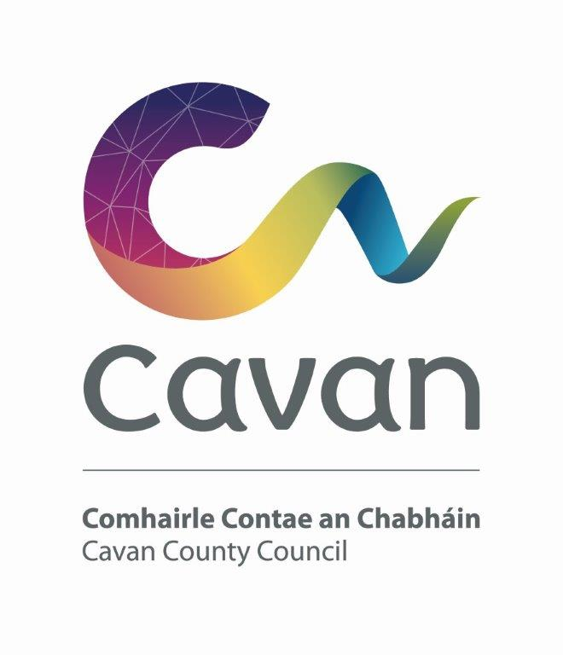

Cavan County Council

Cavan - Belturbet Municipal District

Minutes of Meeting held on Monday 13th November via Teams online.

Presiding: Councillor (Cllr) Aine Smith, Cathaoirleach

Present: Councillors John Paul Feeley, Brendan Fay,
Patricia Walsh and Madeleine Argue.
Apologies: Peter Mc Vitty, Technical issues.

In attendance: Paul Mulligan, SEE, Cavan Belturbet Municipal District Office
Brendan Jennings, Director of Services, Cavan County Council

Also in attendance: Michelle Taite, Anglo Celt.

A G E N D A/ CLÁR

- To consider the draft Municipal District Budget for year ending 31st December 2024 Brendan Jennings Director of Services

Cavan/Belturbet Municipal District Draft Budget 2024

Description | Service | Subservice | Euro
Housing Estate Grants | A01 | A0104 | 25,000
Festival Grants | D06 | D0601 | 7,000
Environmental Grants Agenda 21 | E05 | E0502 | 7,000
Playgrounds | F03 | F0302 | 22,200
Community Grants | F04 | F0401 | 10,000
Discretionary Amenity etc | F03 | F0301 | 120,000
Total |  |  | 191,200

Cllr Feeley proposed the budget. Cllr Fay seconded it.

Meeting closed.

