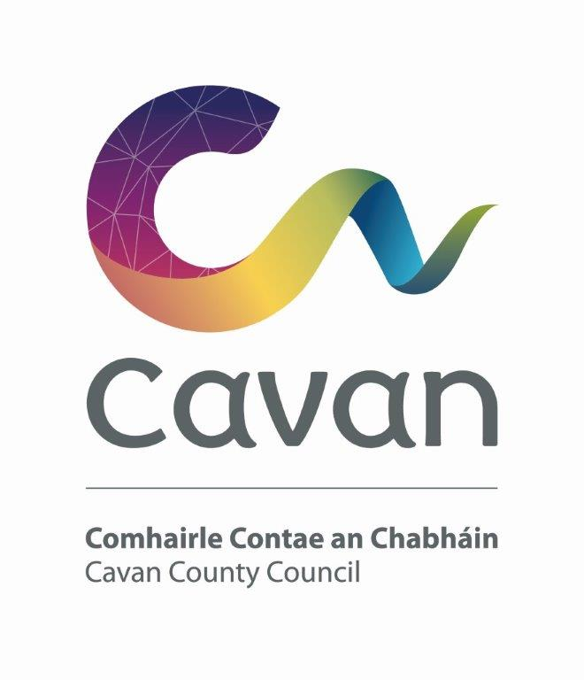

Cavan County Council

Cavan - Belturbet Municipal District

- Minutes of Meeting held on 15th April 2025 in Courthouse, Cavan.
.

Presiding: (Cllr) Patricia Walsh, Cathaoirleach

Present: Councillors John Paul Feeley, Brendan Fay, Niamh Brady, Damien Brady and Áine Smith.

In attendance: Paul Mulligan, SEE, Cavan Belturbet Municipal District Office
Brendan Jennings, Director of Services, Cavan County Council
John Donohoe, Senior Executive Officer, C & E
Also in attendance:
Rosaleen Higgins, Assistant Staff Officer, Minute Taker. Gemma Good, Anglo Celt

A G E N D A/ CLÁR
- Confirmation of Minutes

To confirm Minutes of Monthly Meeting held on the 21.02.25
- Disclosure of Interests (Section 177 Local Government Act 2001)

Business prescribed by Statute, Standing Orders or Resolutions of the Council

- Confirmation of Minutes
Cllr Feeley proposed minutes of last meeting and Cllr Smith seconded.

- Executive Items.
- Appointment onto SLNCR Project - Community Liaison Group for Greenway at Blacklion. Cllr Feeley, Cllr Fay and Cllr Smith,

- Municipal Discretionary Grants 2025 for Cavan/ Belturbet MD. Mr Donohoe presented his report. There were 20 applications, and we have €125,000 to support 16 groups.

- Road Works Programme update Paul Mulligan
Mr Mulligan presented his report. He said about the importance of how we spend a few weeks on the drainage before the surface works start. We have completed drainage on several jobs and others are starting this week.
Table of works below:

- Restoration Improvement Programme 2025
Road Class | Road Number | Road Name and Location | Source | Description of Works | Percentage Completed
R | R-200-3 | Bellavally to Carty’s Bridge / Glangevlin | RI | Road Reconstruction | 15%
Road Class | Number Road | Road Name and Location | Source | Description of Works | Percentage Completed
LS | L-6036-0 | Killynebber | RI | Road Reconstruction | 30%
LT | L-60361-0 | Reservoir Road | RI | Road Reconstruction | 30%
LS | L-5586-0 | Kilmore Upper / Danesfort (Drumhecknagh Rd) | RI | Road Reconstruction | 25%
LT | L-55321-0 | Drumard / Derryniggan, Cavan | RI | Road Reconstruction | 30%
LT | L-15121-0 | Drumard Road | RI | Road Reconstruction | 30%
LT | L-15122-0 | Drummullan | RI | Road Reconstruction | 0%
LS | L-5515-0 | Kilconny-Raheelan, Belturbet (Phase 2) | RI | Road Reconstruction | 0%
LP | L-1069-0 | Whitefield Cross to Ardlougher (Phase 1) | RI | Road Reconstruction | 25%
LP | L-1029-0 | Corracomera Road (Corlough Church Road) | RI | Road Reconstruction | 0%
LP | L-5046-0 | Cloneary | RI | Road Reconstruction | 25%
LS | L-50451-0 | Gortaclogher | RI | Road Reconstruction | 25%
Mr Mulligan stated that sections of the L5586 Kilmore Upper Road were in a bad condition. We had to dig down substantially to find firm ground. It will be strengthened with Macadam.
He also spoke about the L1069 Whiteflield Cross, it needed a lot of drainage, no stone was left unturned.
Cloneary, Bawnboy is well advanced, only a week or two left.
The L2071 Kildallan road is greatly improved, the road is largely widened.
The upgrade at Green Lough Cavan is completed. We have upgraded the car park for wheelchair users. We cleaned up the area the fish shape in the park can now be seen.
Cllr Walsh said it’s great to have such an amenity so near the town and she asked about making repairs to the decking area.
Mr Mulligan spoke about job at Cornagee Viewpoint, his favourite view in the country. The paving was cleaned and repointed and new picnic tables were installed. Also, work has started on another huge amenity in Cavan Town, the Con Smith Park, were works are ongoing.

Cllr Walsh praised Mr Mulligan for his comprehensive report. She commented the pictures tell the whole story.
Cllr Smith congratulated the team, people of Kildallan delighted with job and singing praise off Paul. They have anniversary coming up.
Cllr D Brady started by wishing Dominic Rooney the best in his retirement. He said he was given a great send off and he was a brilliant craftsman.
Cllr D Brady also commented on the fact that White Cross was on the agenda for years and it was great to see it started.
Cllr Fay thanked Paul and his team for fantastic works and photos.
Cllr Feeley also praised works done. He commented if people see work been done, they are happy.
He commented on the good works on Cathederal Road, but drivers insist on blocking the cycle lanes with back of Vechile, could something be done?
Mr Mulligan replied he had a meeting on site and looked at the truck issue. He sees himself vehicles overhanging. Two options were Bollards or small blocks. Active Travel are reviewing it.
Cllr D Brady had mentioned Templeport to Gortnaleck and Mr Mulligan said it will be considered for a future RI Programme.
Mr Mulligan asked Councillors to tell him about any roads issues they see, and he will put them on the list.
Cllr D Brady asked about Budget for surface dressing. Mr Mulligan responded saying it is the same as previous years/
Cllr N Brady talked about the walkway in Drumalee is great, but the dog bins are full of beer bottles and rubbish bags dumped around the bins.
Mr Mulligan said there is a big problem with waste county wide. In Belturbet a problem with people dumping their household waste in public bins.
Cllr Fay bins are vandalised and full of household waste especially on Turbet Island. He asked could the media highlight the issue, saying do not dump your household waste or the bins will be removed.

Members Items

- That safety measures be implemented at the Junction of the N16 & Florencecourt Road in Blacklion.
Cllr Feeley
Cllr Feeley said cars are not stopping going into Blacklion, more signage is needed telling them to stop. They cross a pedestrian crossing but do not stop or at the Diamond.
Cllr Feeley is constantly getting reps about this. It acknowledges it is a complicated junction, but we need to address the problem there. At least they cannot travel at speed.
All councillors support the motion.
Mr Mulligan says there is issue at this junction. People are parking at the Pedestrian Crossing. There is a stop sign, but he agrees there is a need to add more advance signage. But it is difficult to locate a place to put the signage. He says we will review it.

- To seek an update from Waterways Ireland on the development of plans to extend the Shannon Navigation north of Lough Allen towards Dowra and that we seek a meeting, in conjunction with Leitrim County Council with Waterways Ireland to discuss the matter. Cllr Feeley

Cllr Feeley says Waterways Ireland have engaged consultants. It will be a huge benefit to Dowra to have it completed. He asks can we contact them and keep the pressure on.
All councillors supported the motion.
Mr Jennings said it is in the Shannon Plan and Waterways Ireland are main driver on it. There are several projects, Lough Allen Master Plan and Spenser Docks.
Cllr Feeley asks that we engage
- Junction signage in Cavan town. Cllr Smith
Some of the driving schools asks can road marking in the town be done again as students are failing their driving test because of the wear and tear. All over town lineage needs to be re painted.
She also comments that the traffic light at Drumalee has no filter light.
All councillors support the motion with Cllr D Brady saying markings bad at Cavan Crystal and people may fail their test because of this.
Mr Mulligan said we will get Kelly Contractors booked to do this. There is a surfacing issue at Cavan Crystal.
Mr Mulligan confirmed that there is a filter light at Drumalee and it was working but will check it again. Cllr Smith said she never seen it working.
Mr Jennings said it needs to be checked and if they notice this at any other junctions, let Mr Mulligan know.
- Statue and area at Aghalane Bridge Cllr Smith

Cllr Smith requested a clean-up at Aghalane Bridge. She says the statue is beautiful, it represents such a significant thing and is not as visible as it used to be. The area has become overgrown.
Cllr Feeley supported the motion saying it looks poor and is a very significant piece of craftwork and need to be cleaned, it is the first thing people see when entering County Cavan.
Cllr Fay said the Tidy Towns used to go out and tidy around it, but most members now are over 70. He also requested a clean-up.
All councillors support the motion.
Mr Mulligan replied by saying he does not think it looks terrible, it is in good condition in his eyes. He acknowledges that a bit of works needs to be done. He will ask the contractor to do hedge cutting. One tree blew over in the storm. We have a lot of priorities clearing trees from the walkways.

- That we ask the council to look at our roads verges that are totally dangerous.
And several accidents have occurred with absolutely no protection for road users especially the Drumalee road (R197) also speed on this road & the L1504 in Milltown Cllr Fay

Cllr Fay said he gets a lot of reps on this. On the Drumalee road there is a lot of accidents, the sides are soft. People are disappointed, the speed limit lowered to 80, it should be 60.
Trucks are speeding at Gannons Cross.
At Milltown cars gone in there. What can be done, he asks.

All councillors support the motion.

- That we look at the median and crosswalk at turn in of Furnaceland
in Swanlinbar.
4/5 businesses with oversized trucks cannot make the turn. And some have capsized and have had serious cost to their business. Cllr Fay

Cllr Fay said Businesses in Swanlinbar have a problem with the Median, trucks can not turn. There was an accident last week, cargo came of a truck, and it was destroyed. He asks can the Median be moved back from the Junction.

Mr Mulligan replied that a redesign will be undertaken and that following this, funding will be applied for, to implement the works.
It will go on a future programme.

- Unruly teenage behaviour at Con Smith playground. Cllr N Brady

Cllr N Brady said she gets a lot of reps on this. She witnessed the behaviour herself. Teenagers jumping on the slide and running across the bridge whilst children trying to use Monkey Bars. Children are afraid of the teenagers who are also vaping under the slide. She suggested a warden for the park. Also dogs off their leads are a problem. Maybe signage too.
All councillors support the motion and have had reps on this.

Mr Jennings replied that he thinks a warden would not solve the problem, it’s a social issue. We need more facilities for teenagers. Parents need to take responsibility; the Council cannot solve all issues. It’s a difficult area.

All Councillors support the motion. Cllr Fay said Bounce Back in Belturbet is brilliant, teenagers go fishing, have soccer and a variety of activities. He says the more you give children to do the better.

- Footpaths at Railway Road, Cavan Cllr Walsh

Cllr Walsh says the footpaths from Rudden’s to McMahons are dangerous and need repairs.
All councilors support the motion.
Mr Mulligan replied that Uisce Eireann are upgrading the area out to the hospital. Active Travel is facilitating them and say footpaths will be improved in 2026. And that road is on our RI programme for 2027.

- People without phones since Storm Éowyn. Cllr Walsh

Cllr Walsh highlighted the issue of elderly people in Cavan Town still without a phone since the storm. A lot of pensioners rely on the phone for their personal alarm system. People should not be insecure in their home.
All councillors supported the motion. Cllr Smith asked can you call 999 with out cover.
Cllr Walsh said she would chat with the alarm company people she has the number.

AOB

Cllr Damien Brady highlighted the issue of the killing of sheep belonging to farmers in the west at Glan and Tullydemont Falls. People are letting dogs out without leads. There is an open area, and dogs are allowed to roam freely causing havoc. There are no signs up saying to keep dogs on leads and he asks can we erect signs.
Cllr Feeley agrees animals should be kept under control.

Mr Jennings replies that he understands the request and supports farmers. It is down to people’s behavior and a small group destroy all for everyone else.
He will see if we can do anything under Geopark Maintenance.

Date set for next meeting 23.05.25 at 10 am in Church Street Ballyconnell. Liam, our plumber, met with Gayle from the Bayleaf about the heating issue and she was happy it was resolved.

Meeting closes at 11.15

