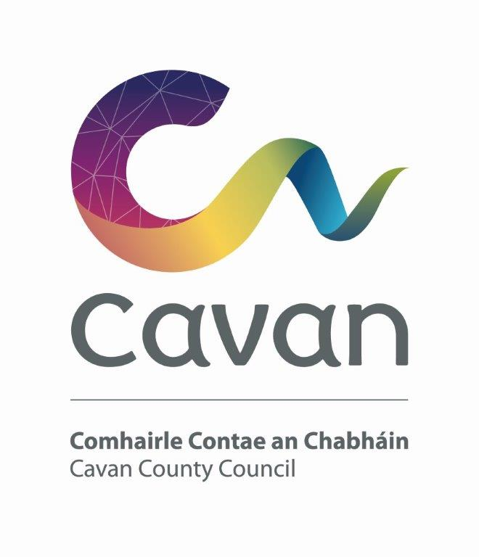

Cavan County Council

Cavan - Belturbet Municipal District

Minutes of Meeting held on Monday 6th November 2023.

Presiding: Councillor (Cllr) Áine Smith, Cathaoirleach

Present: Councillors John Paul Feeley, Brendan Fay, Peter McVitty and Madeleine Argue.
Apologies: Cllr Patricia Walsh

In attendance: Paul Mulligan, SEE, Cavan Belturbet Municipal District Office
Brendan Jennings, Director of Services, Cavan County Council

Also in attendance: Derry Scanlon, Senior Executive Engineer, C & E
Gabriel Hurson, Executive Engineer, C & E
John Donohoe, Senior Executive Officer, C & E
Michell Taite, Anglo Celt.
Rosaleen Higgins, Assistant Staff Officer, Minute Taker.

A G E N D A/ CLÁR
- Confirmation of Minutes

To confirm Minutes of Monthly Meeting held on 22nd September 2023
- Disclosure of Interests (Section 177 Local Government Act 2001)

Business prescribed by Statute, Standing Orders or Resolutions of the Council

- Confirmation of Minutes
Cllr Feeley proposed minutes of last meeting and Cllr Mc Vitty seconded.

Executive items

Presentation of the Con Smith Masterplan by Paul Hogarth Company.

Mr Hennessy from Paul Hogarth Company made the presentation. He told the meeting that the project must be done to the highest quality. Funding of half a million euro has already been allocated to the project under the Towns and Villages fund. He detailed what was proposed for every area of the park including:

-Better Pathways.

-Expanding of the River to increase wildlife in the area.

-A community orchard area.

- Refurbishment of the bridge.

- Improvement of the current playground facilities and skatepark.

- Possibility of a new Basketball Court.

He explained that the park had a couple of different functions. He hopes the area can work as a centrepiece for the new Cavan Institute Campus and will have strong links to the town centre.

While the Councillors were content with the Masterplan, they had a few concerns.

Cllr Feeley mentioned that the company were trying to fit too much into such a small park could be counterproductive.

Cllr Fay stated that many basketball courts had been created around the area and are now dark spaces due to a lack of interest in the sport.

Cllr Mc Vitty asked would there be any extra parking spaces.

Cllr Smith said how she loved visiting the park with her children and feeding the ducks, however Cllr Argue interjected to say the ducks are gone!

The next stage of the development will reveal the plans in closer detail and outline a timeline of the projects.

Roads programme

Mr Mulligan presented his engineers report on projects on going and finished, table below.

Photo of Jampaling on front of report. Cllr Smith lives near Jampaling and complimented the photo.

Mr Mulligan thanked all his team, contractors, and suppliers for their continued good work.

Cllr Smith thanked Mr Mulligan As Gaeilge for his good work.

- Restoration Improvement Programme 2023
Road Class | Road Number | Road Name and Location | Source | Description of Works | Percentage Completed
R | R-205-0 | Doon (Ed Ballyconnell) Ballyconnell Main street | RI | Road Reconstruction | 15%
R | R-201-2 | Killeshandra-Miltown (Keelagh-Derrygid) | RI | Road Reconstruction | 95%
R | R-200-3 | Tullynacross-Dunmakeever | RI | Road Reconstruction | 100%
Road Class | Road Number | Road Name and Location | Source | Description of Works | Percentage Completed
LP | L-1518-0 | Knockateery-Drumbrawn | RI | Road Reconstruction | 100%
LS | L-2538-0 | Cock Hill (Dunnes stores to Gaelscoil) | RI | Road Reconstruction | 95%
LT | L-5538-0 | Latt-Keadew | RI | Road Reconstruction | 70%
LP | L-1508-0 | Drumerdannan-Derryvackny(killeshandra to Butlersbridge) | RI | Road Reconstruction | 100%
LP | L1030-0 | Bawnboy-Erraran (Marsh rd) | RI | Road Reconstruction | 100%
LT | L-50231-0 | Tullyloughfin/Altachullion Upper | RI | Road Reconstruction | 100%

Members Items

- Need to implement safety measures in Corratillan on the Swanlinbar to Ballinamore road. Cllr Smith

Cllr Smith expressed her concern at people travelling at high speed on this road, some measure needs to put in place to reduce speeds.
Cllr Mc Vitty, Cllr Fay, and Cllr Feeley all supported the motion.
Mr Mulligan stated that under SIW(Safety Improvement Works) programme, he has put in for funding for this. He said there is signage there. A body of work needs to be done. Hopefully we will get funding in 2024.

- Traffic issues at Loreto Cross, Cavan. Cllr Smith

Cllr Smith said it is very dangerous for anyone turning into the school from both directions. She said there is very little room to turn when coming from Butlersbridge road. She also stated that many motorists experience a lot of delays there due to traffic and she is eager to see anything done to ease the danger.

Mr Mulligan said he would get the road assessed. He pointed out that if it was easier to turn it would increase the speed people drive at. Mr Jennings agreed and stated that a lot had been done to that specific area of road already.

Cllr Smith queried can we collaborate with school in relation to staggering start and finishing times of school, to reduce traffic. She expressed her concern that it is also on route to the hospital and an ambulance would not get through at peak times.

Mr Mulligan agreed to assess the area under the active travel scheme.

- The need for safety barriers on Glan Gap. Cllr Feeley

Cllr Feeley highlighted the dangerous section of the R200. He said several years ago, safety barriers were installed on parts of the road at the top of the gap, and they substantially reduced the risk to road users. Other stretches of the road require the same attention,
In the area of Gilvanny there is no signage at all.
Cllr Vitty supported the motion along with Cllr Smith and Fay.
Mr Mulligan agreed with the councillors. The Council needs to look at the road as a whole and agreed that a safety barrier would be a good short-term solution but it extremely expensive and nothing in our budget for it. Maybe the members could explore funding.

- The illumination of the bridge on the N3 over the River Erne.

Cllr Feeley &Cllr Fay

Cllr Feeley said the bridge is one of the two cable stayed bridges in the country and the first of its kind in Ireland and UK. It should be lit up to allow to be seen in the dark.

Cllr Fay supported the motion and suggested naming the bridge. He proposed a competition where people could write to the Council and make suggestions.

Cllr Smith also supported the motion and proposed naming the bridge As gaeilge

Cllr Mc Vitty also supported the motion.

Mr Jennings said there would be no power supply.

Mr Mulligan said it was not considered at the time as there may be issues with nature/environment and power supply.

- Amenities at Killymooney Lake. Cllr Walsh
- Safety measures at Killygarry Church & School. Cllr Walsh

Deferred. Cllr Walsh not in attendance.

- Update on Milltown traffic control. Cllr Fay
Cllr Fay stated that Milltown NS Parents Association has applied for planning permission for a modular unit. They need to put a traffic plan in place.
Mr Mulligan stated that we were working there currently. And we were completing the following works.
-signs for one way system, informal at school times.
-extending lighting out to gateway.
-signage coming into the village.
Cllr Fay thanked Mr Mulligan.
AOB
Cllr McVitty mentioned the problem of traffic at NS in Killeshandra. They have two new classes for children with special needs, extra traffic coming into area. Need traffic calming measures.
All councillors supported the motion.
Mr Mulligan stated that Clar in consultation with the school and flashing lights already in place.
Cllr McVitty acknowledged that work done but with the children attending the school with special needs, more needs to be done. Parking is an issue.
AOB
Cllr Fay inquired is there any funding for Belturbet Jetty. It is not in good shape.
Mr Mulligan said it is unsafe, it is cordoned off. No funding available to do a good job. “what we do, we do right” he said. Maybe contact Waterways Ireland, raise it with the SMT of the Council.

Meeting closed 5.45.

