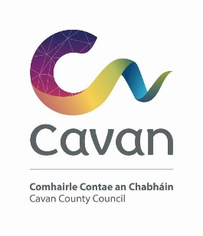

Cavan County Council

Cavan Belturbet Municipal District

16 May 2025

To Cathaoirleach and Each Member of The Cavan Belturbet Municipal District

Dear Councillor,
The next meeting of Cavan Belturbet Municipal District will be held in the Community Centre Ballyconnell -
- On Friday 23rd May at 10.00 AM.
.

The agenda is overleaf.

Yours sincerely

__________________
Meetings Administrator

A G E N D A/ CLÁR
- Confirmation of Minutes

To confirm Minutes of Monthly Meeting held on the 15.04.25

- Disclosure of Interests (Section 177 Local Government Act 2001)

- Correspondence- Email from Waterways Irl acknowledging our letter and they will get back to us in due course.
Business prescribed by Statute, Standing Orders or Resolutions of the Council

- Executive Items-
- Part 8- Seamus Mc Loughlin, Senior Executive Engineer- below:
“Demolition of 7 No. dwellings (Nos 13-19 St. Brigid’s Terrace inclusive),
Development of 20 No. own door residential units split over 2 No Blocks:
Block A is two storey high and consists of 4 No 2 bed apartments, located at ground floor level and 4 No 1 bed Apartments located at the first-floor level. Block B is three storey high and consists of 6 No 2 bed duplex units, located at lower ground and ground floor level and 6 No 1 bed apartments, located at the first-floor level.
Car Parking and Bicycle Parking Provision, Pedestrian Access steps connecting Dublin Road and the LP 6623 (Road at rear of existing St Brigid’s Terrace), Public Lighting, Connection to public sewer, watermain and surface water and Erection of boundary treatments and retaining structures and all associated site works including provision of pedestrian footpath as indicated at Townparks ED, St Brigid’s Terrace, Old Dublin Road, Cavan. “

- Road Works Programme update Paul Mulligan

Members Items
- That we look at the new speed signs. Some places are very confusing with 2 different signs on roads
And if we could get speed signs at all our schools not the default black lines signs. Cllr Fay

- That we look at the speed, going through the town of Belturbet.
Cllr Fay

- Foothpath at Rakeleen, Ballyconnell. Cllr D Brady

- Age Friendly Parking in our towns and Villages Cllr D Brady.

- Use of solar signs in rural areas for warning signs. Cllr Smith

- Bus shelter update. Cllr Smith

AOB
Date of next meeting. (AGM)

