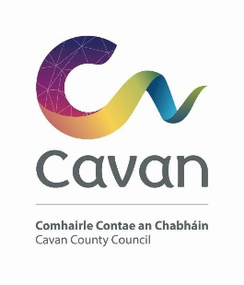

Cavan County Council

Cavan Belturbet Municipal District

04 June 2025

To Cathaoirleach and Each Member of The Cavan Belturbet Municipal District

Dear Councilor
The Annual General Meeting of Cavan Belturbet Municipal District will be held in
- The Meeting Room, Town Hall Cavan
- On Monday 9th at 1.30pm
The Order of Business is as follows: -

- Declaration of persons duly elected as members of Cavan – Belturbet Municipal District (Local Government Act, 2001 (as amended))
- To elect a Cathaoirleach for the coming year (Local Government Act, 2001 (as amended))
- To elect a Leas Cathaoirleach for the coming year (Local Government Act, 2001 (as amended))
- To approve the minutes of the Annual General Meeting held on 21st June 2024.

__________________
Meetings Administrator

