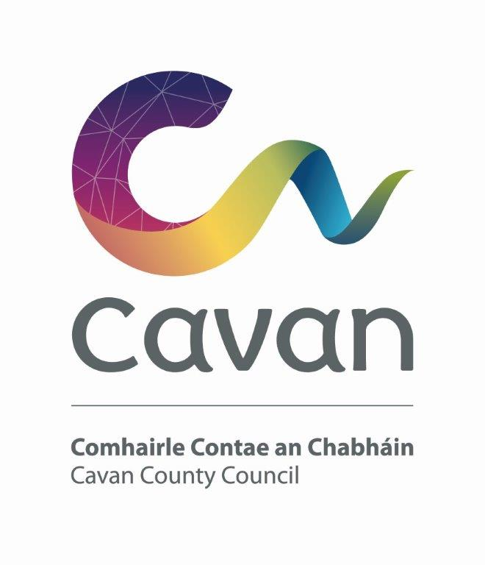

Cavan County Council

Cavan - Belturbet Municipal District

Minutes of Meeting held on 19th March 2024

Presiding: Councillor (Cllr) Áine Smith, Cathaoirleach

Present: Councillors John Paul Feeley, Brendan Fay, Peter McVitty, Madeleine Argue and Patricia Walsh

In attendance: Paul Mulligan, SEE, Cavan Belturbet Municipal District Office
Brendan Jennings, Director of Services, Cavan County Council

Also in attendance:
Derry Scanlon, Senior Executive Engineer.
Seamus Enright, Anglo Celt
Rosaleen Higgins, Assistant Staff Officer, Minute Taker.

A G E N D A/ CLÁR
- Confirmation of Minutes

To confirm Minutes of Monthly Meeting held on Monday 26th February 2024.
- Disclosure of Interests (Section 177 Local Government Act 2001)

Business prescribed by Statute, Standing Orders or Resolutions of the Council

- Confirmation of Minutes
Cllr Feeley proposed minutes of last meetings and Cllr Mc Vitty seconded.

Cllr Smith welcomed everyone to the meeting in Irish and the meeting proceeded.

She expressed her delight at the funding of €114000 for further improvement works at Bawnboy Workhouse. She mentioned her late Dad would have worked on this project. She thanked Mr Jennings and his team for securing funding.

Executive items

Mr Derry Scanlon gave a brief talk and presented his report on the plans to undertake works at Mooney’s Hall & Fair Green, Blacklion as stated below.
To approve report in accordance with Part VIII of the Local Government (Planning & Development) Regulations 2001–2008 (Article 81) to undertake the following works at Mooney’s Hall & Fair Green, Blacklion. The proposal is for the following;
- Demolition of the existing unoccupied Mooney’s Hall Building
- Construction of new 2-storey Co-Working facility consisting of shared office spaces, meeting rooms and all associated ancillary spaces
- Construction of new single storey Community Centre consisting of hall space, canteen/kitchen, sanitary facilities, and all associated ancillary spaces.
- Construction of new car park and all soft and hard landscaping
- All ancillary site works necessary to facilitate the development.

Statement from Senior Planner Nicholas O Kane:

I recommend approval of the Section 179 development, having regard to the assessment and reasons in the attached area planner’s report. The proposal is considered to be in accordance with the 2022-2028 Cavan County Development Plan incorporating a Local Area Plan for Cavan Town and the proper planning and sustainable development of the area.

Cllr Feeley was delighted to see the plan to put this area of Blacklion back to good use. He mentioned the plans were exciting and new parking spaces in Blacklion will be very welcome.

All councillors supported the Part VIII proposal and thanked Mr Scanlon for his presentation.

Cllr Walsh wanted to congratulate Loreto College Cavan on their all Ireland U16 win.

She was a proud grandmother, her granddaughter was on the team.

Cllr Argue also commended the girls and their coaches and asked Cavan County Council to respect the girls.

Cllr Smith also delighted with win as a past teacher and trainer of the girls.

All councillors were delighted for Loreto and mentioned Centenary Celebrations in St Patricks College. Cllr Argue praised the Music and speeches.

Cllr Smith and Cllr McVitty mentioned how they had attended St Patricks day parades in Ballyconnell and Killeshandra.

Cllr Smith mentioned how RTE attended the parade in Killeshandra and Trump and Kate Middleton also turned up!

Swanlinbar had a good parade too.

Mr Jennings said it was a pity there was no parade in Cavan. The Council supported the parade financially, but the problem was there was no volunteers to organize it. On the plus side the people of Cavan attended the nine other parades in the County, and they were a great success. Their organisers are to be commended.

Road’s programme

Mr Mulligan presented his engineers report.

He referenced job ongoing at Killymoriarty, every inch was drained. He talked about the mundane job of scrapping the sod of the road but necessary for better finish.

He spoke about the drainage ongoing on Tullynafreave known locally as the Trunk Road and how it ties in with the Kingfisher trail and drainage ongoing on the L1532 Old Cavan Road at Butlersbridge.

He praised Bernie, the horticulturist, works in Cavan town, the mature laurel hedge at Swellan and the beautiful daffodils in Egg market with the river in the background.

He mentioned the stone wall under construction at Glangevlin and emergency repairs at Kildallan on the L5070. And the erecting of new fencing at Mount Pleasant Ballyconnell ongoing.

Finally, Paul mentioned the challenges of the wet weather and how it is affecting the roads.

Cllr Walsh thanked Paul and his photography skills and also thanked Bernie; flower arrangements lovely.

All councillors thanked Mr Mulligan. Cllr McVitty said, “the work done right”.

Cllr Feeley endorsed all the works. Mentioned the deterioration of roads in West Cavan. Impossible for Mr Mulligan to monitor all. Management in the Council, Mr Connaughton needs to liaise with Coillte about road damage.

Members’ Items

Cllr McVitty had a late motion, not on the Agenda, only just happened. The plan to only open Ballyconnell Garda Station for four hours per day.
Cllr McVitty said people are shocked by the decision to close the station to the public outside of several hours in the early morning and again in the evening.
He is completely opposed to this. He says it can not be allowed to happen. It is too big an area, stretching from Belturbet all the way to Dowra and Carrigallen to the border. He called for the Councillors support and all members supported the motion.
With Cllr Feeley saying the decision must be reversed, not enough guards in the West.
Adjourned items:
- Safety measures at Killygarry Church & School. Cllr Walsh

Cllr Walsh was approached by parents who were concerned about traffic and speed of traffic at the school. Cllr Feeley supports the motion saying that traffic is using the old road to avoid the delays. Cllr Argue support the motion saying, “speed on the road amazing and it raining a no no” All other councillors supported the motion.

Mr Mulligan had a report from Road Design on the area, and it does not meet the criteria for a reduced speed limit or public lighting. But Road Design will keep monitoring the issues.

- Appearance of houses on way into Cavan Town, College Street
Cllr Argue
Cllr Argue mentioned when she is travelling on a bus into Cavan Town, you really notice the state of the vacant houses on College Street.
Cllr Walsh said there was a picture in the papers recently of a tree growing out of a house chimney. The main approach into Cavan is an eyesore.
Mr Jennings said we would issue notices on the derelict sites and work with property owners. He says the council has option to buy the properties. But he would like owners to take ownership and make use of it, there are grants there to help. He hopes there will be positive change from College Street out,in years to come.
Cllr Fay said grants are good, but you need money upfront. He knows people that went to bank for loan to renovate vacant properties, but they needed collateral . Case of “the chicken or the egg”
3. Cavan Tidy Towns looking to implement Green Kilometre project in Cavan Town Cllr Argue
Cllr Fay said Maria from litter Management involved in this. They will supply equipment needed to keep your area clean. This project is in existence these last few years.

1.Concern about items been sold in Vaping Shop in Cavan Town.

Cllr Walsh

Cllr Walsh concerned about the vaping shop in Cavan Town, it looks like and American Candy shop from the outside, but they are selling vapes. She said young people are in it all the time. Who monitors these shops? Sweets drawing the children in.

Cllr Feeley supports this motion commenting strange mix, sweets, and these other products.

Cllr Fay said act brought into law in September making it an offence to sell these products to under 18’s but is it been enforced.

Cllr McVitty said vaping a serious situation with the young people.

Mr Jennings responded by saying he check with Planning department, and they have permission to trade as a retail store.

2. Need to upgrade Killeshandra Crossdoney Cavan road.
Cllr Smith
Cllr Smith spoke of the very heavy traffic on this road. A lot of heavy vehicles from Lakeland dairies travelling the road. She welcomes all the new jobs generated by Lakeland dairies. Road not suitable for all the heavy traffic.
Cllr Feeley said the had the same motion last year. Welcomed the works done by the Ballyjamesduff MD. He said we need Lakeland Dairies to continue to prosper and the road need continuous upgrading. All councillors support the motion.
Mr Mulligan says yes, this motion on the Agendas for years. He says we looked for funding and meeting with the landowners. But the road needs a complete realignment, and it would cost millions. He complemented the work done to date by council employees in the Ballyjamesduff MD Area.
3. Walkway enhancement on Turbet Island Cllr Smith
Cllr Smith commented that Turbet Island is a great asset to Belturbet. She said we need to utilise it and make it better. She asked can the Council promote it with advertising and a marketing campaign. All councillors supported the motion.
Cllr Fay responded by saying that a sum of €30000 was obtained to repair and enhance the walkways on Turbet Island. He said the council are supporting several initiatives to build a suite of amenities for tourists in the area. The monies secured would go a long way in upgrading the walkways on the Island some of which were very damaged by the storms. He stated that it’s a prominent site and one that the town is rightly proud off.
4. Update on Traffic Calming measures in Killeshandra
Cllr Feeley
Cllr Feeley said there was a real fast flow of traffic past the health centre that needs addressing. He stated we need to protect pedestrians. All councillors support the motion.
Mr Mulligan responded by saying an examination of the area by the Road Design team did highlight an issue with speed. We are awaiting feedback from the team. Funding is likely to be an issue.

- Progression of the development of the ‘Brian Boru’ Road
as a walking and cycling amenity. Cllr Feeley
Cllr Feeley asked about the prospect of progressing plans to develop what is know locally as the Brian Boru Road as a walking and cycling amenity for the west. Historically it was built as a roadway for the McGovern clan.
He said that seen as Greenways are being developed in the County, it is important to keep this on the Agenda.
All councillors supported the motion.

Meeting closed at 5pm.

Signed:----------------------------

Date:-----------------------------------

