.
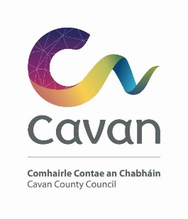

Cavan County Council

Cavan Belturbet Municipal District

13 March 2024

To Cathaoirleach and Each Member of The Cavan Belturbet Municipal District

Dear Councillor
The next meeting of Cavan Belturbet Municipal District will be held in Templeport Community Centre.
- On Tuesday 19th March at 3.00 pm.

The agenda is overleaf.

Yours sincerely

__________________
Meetings Administrator

A G E N D A/ CLÁR
- Confirmation of Minutes

To confirm Minutes of Monthly Meetings held on 26th February 2024

- Disclosure of Interests (Section 177 Local Government Act 2001)

- Correspondence- None
Business prescribed by Statute, Standing Orders or Resolutions of the Council

- Executive Items
To approve report in accordance with Part VIII of the Local Government (Planning & Development) Regulations 2001–2008 (Article 81) to undertake the following works at Mooney’s Hall & Fair Green, Blacklion. The proposal is for the following;
- Demolition of the existing unoccupied Mooney’s Hall Building
- Construction of new 2-storey Co-Working facility consisting of shared office spaces, meeting rooms and all associated ancillary spaces
- Construction of new single storey Community Centre consisting of hall space, canteen/kitchen, sanitary facilities, and all associated ancillary spaces.
- Construction of new car park and all soft and hard landscaping
- All ancillary site works necessary to facilitate the development.

Statement from Senior Planner Nicholas O Kane:

I recommend approval of the Section 179 development, having regard to the assessment and reasons in the attached area planner’s report. The proposal is considered to be in accordance with the 2022-2028 Cavan County Development Plan incorporating a Local Area Plan for Cavan Town and the proper planning and sustainable development of the area.

Report attached.

- Road Works Programme update Paul Mulligan

Members Items

Adjourned items from last meeting:

- Safety measures at Killygarry Church & School. Cllr Walsh

- Appearance of houses on way into Cavan Town, College Street
Cllr Argue
- Cavan Tidy Towns looking to implement Green Kilometre project in Cavan Town Cllr Argue

Members Items
1. Concern about items been sold in Vaping Shop in Cavan Town.
Cllr Walsh
2. Need to upgrade Killeshandra Crossdoney Cavan road.
Cllr Smith
3. Walkway enhancement on Turbet Island Cllr Smith
4. Update on Traffic Calming measures in Killeshandra
Cllr Feeley

- Progression of the development of the ‘Brian Boru’ Road
as a walking and cycling amenity. Cllr Feeley

