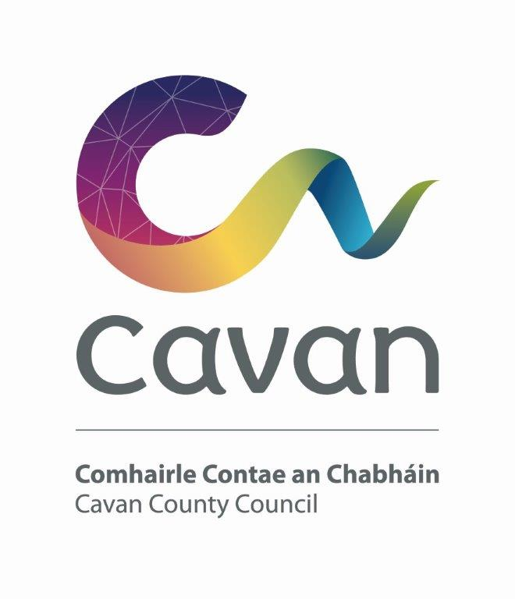

Cavan County Council

Cavan - Belturbet Municipal District

Minutes of Meeting held on 20th September 2024 in the Town Hall Belturbet

Presiding: Councillor (Cllr) Patricia Walsh, Cathaoirleach

Present: Councillors John Paul Feeley, Brendan Fay, Niamh Brady, Damien Brady and Áine Smith.

In attendance: Paul Mulligan, SEE, Cavan Belturbet Municipal District Office
Brendan Jennings, Director of Services, Cavan County Council

Also in attendance:
Aisling Kiernan, Anglo Celt.
Rosaleen Higgins, Assistant Staff Officer, Minute Taker.

A G E N D A/ CLÁR
- Confirmation of Minutes

To confirm Minutes of Monthly Meeting held on the 15 July 2024.
- Disclosure of Interests (Section 177 Local Government Act 2001)

Business prescribed by Statute, Standing Orders or Resolutions of the Council

- Confirmation of Minutes
Cllr Walsh proposed minutes of last meetings and Cllr Feeley seconded.

Matters arising from previous minutes.
Cllr Walsh asked Mr Mulligan was there any progress on Derrygoss.
Mr Mulligan confirmed that he is looking at it legally, he seen the cracks in the wall. Traffic still ignoring the signs. Cllr Walsh reiterated it not fair on the people and she asked Paul to look at it again.

- Executive items

- Road Works Programme update Paul Mulligan
Mr Mulligan presented his report. Mr Mulligan said that most works are completed. Roadworks are completed at Swellan\Drumnavanagh, St Patricks Tce, Glenside Rd, Loreto Road, Raheelan-Greathill, Killymoriarty, Kilsob and Drumcrow. Local improvement scheme is also complete at Drumoghra.
Works in progress are Dowra’s Main Street and the following are partially complete, Drumalee Road, Creenagh Clebe, Tullynafreave, Dunmakeever and Annagh Park. Going forward we will work on the remainder of the RI’s and Climate adaptation scheme.
He complimented his staff, outdoors and indoors on the excellent job they are doing.
All councillors praised Mr Mulligans report. Cllr D Brady complimented the staff and said with the good weather is chance to get drainage done. He complimented works done on Eugene O Reilly park and asked could the mound of soil be removed
Mr Mulligan said we must be careful as there is Japanese knotweed in the area.
Cllr Feeley compliments staff on the Killeshandra road, surface very good. He asked could we look at grass verges as they are very overgrown in places.
Cllr Smith asked was the Japanese knotweed at Caffreys Cross been treated. She also wanted to know have we sent out hedge notices.
Cllr Fay asked was there any update on flashing lights at Killynagher. He asked can we look at Gullys at Killeshandra Graveyard.
He said the Tidy Towns were asking what can be done about the Knockweed. He complimented Bernie our horticulturist on the information she gave them about it.
Mr Mulligan responded that the Knotweed at Caffreys Cross is extensive and would need several treatments and would take significant resources.
He said the problem with hedge notices is some cut them, and some do not. We need to take someone to court to create a precedent.
Mr Jennings said more is done now than in the past.

Members Items
1. Teenagers/Children’s amenities Cavan Town Cllr N Brady
Cllr N Brady congratulated all that competed and won at the 2024 Fleadh. Several all-Ireland titles were won bringing tremendous pride to our county. She also congratulated Cllr Walsh in her role.
Cllr N Brady expressed her shock at lack of amenities for teenagers in the county. She suggested a survey for children to find out what they facilities they want for their area. Not all children are into sport.

She was at an exhibition in the library recently, where there an exhibition of local children’s thoughts on where they live. She was dismayed to read that some children do not feel safe and said there was nothing to do.
All councillors supported the motion.
Cllr Smith suggested a café. Cllr Walsh said anything to get the children away from the phones. She said Foroige in Bridge Street have a Café, it needs volunteers, parents need to get involved.
All councillors agreed little for teenagers to do. Cllr Smith said ETB did survey and suggested we talk to them.
Mr Jennings joked when he was young the facilities were the fields! He said there is a great development plan for Con Smith Park, which will provide more facilities.

2. Playground at Killykeen Cllr N Brady

Cllr N Brady said it was a shame no playground in Killykeen forest park.
Mr Jennings said a natural playground a good idea like at Rossmore. He said he just signed off on one for Dun A Ri forest park. The are doing a Masterplan for Killykeen but it not advanced yet.
All councillors supported the motion

- Carrickane Rd from Loreto Cross to Hospital Cllr Á Smith
Cllr Smith said the junction was a nightmare in the morning and evening at school times. She worries if an ambulance would not get through. Also, the condition of the road is bad. She suggested contacting the principal of the school to see if anything could be done to improve the flow of traffic.
All councilors support the motion.
In response Mr. Mulligan said our Active Travel Section did a lot of good work at the junction and as for the state of the road the holes will be repaired in due course.
Mr. Jennings said he travels the road himself, but he leaves early in the morning and it is not an issue, it has to be finely timed.

- Works needed at junction at Sheehan’s and road to graveyard in Kildallan Cllr Á Smith

Cllr Smith said this was raised before. Junction at Sheeans dangerous and the road to Kildalan graveyard, no space for two cars to pass. Can the road be widened.
All councillors support the motion.
Mr Mulligan said we will look at it. The two roads to Kildallan need work. We will see about putting it on Roadworks Programme for the next three years. There are a few roads in the Kildallan, Killeshandra road that need attention, and he welcomes all reps in this regard. To widen a road, we need landowner agreement and funding, or this would not fall under the RI scheme maybe under a CIS scheme.

- Outdoor facilities at lock No 2 Ballyconnell Cllr D Brady
Cllr D Brady highlighted how the area was part of the Shannon/Erne Waterway that incorporated a cross-border community initiative for those interested in White Water Rafting.
He said people are changing the carpark, there needs to be proper changing facilities installed like facility at Brackley Lake. Also, car parking is an issue.
All councillors support the motion.
Mr Mulligan said we will investigate it.

- Greenway connecting Corlough Gaa grounds with Corlough School and Chapel Cllr D Brady
Cllr D Brady says we are in the heart of the Geopark, people come from all over to visit. Could we connect Corlough GAA grounds to the chapel by a walkway.
Cllr Feeley and Cllr Smith support the motion.

Mr Mulligan responded saying that a business case should be put together for funding. 3.5Km is a long distance to fund for a walkway. Would the cost benefit make sense in this size of a project. It would be difficult to secure funding.
Mr Jennings said it not that long of a distance for a walkway. Ballyconnell was developed because off the population. We can look at it, but land ownership would be a problem.
Cllr Brady said not a long distance, and would encourage children to walk and there is lovely scenery over to Blackrocks.

- Upgrade of the Tractamotors Junction, Cavan Town to address the on-going delays for traffic and the disruption to residents.
Cllr Feeley\Cllr Walsh
Cllr Walsh said this motion has been on the Agenda umpteen times. It is a nightmare junction. It took her 40mins to get to Cavan General from St Martins Estate. What can be done? Minister Jack Chambers seen the junction when he visited. The bypass did nothing to help.
Cllr Feeley said he raised it several times. Some issues were addressed some were not. He wanted to know is there a plan, what is happening about it. Residents cannot get out onto road with the volume of traffic causing big disruption to all.

All councillors supported the motion, some suggesting again why can we not stop traffic turning right at Tractamotors.

Mr Mulligan responded saying he understood councillors’ frustration. Study after study completed. He did suggest inside of doing a trial, of no right turn. A roundabout will not fit. Traffic volumes beyond capacity at certain times. “We hear it” Mr Mulligan says. “Something needs to happen, bring it inside”

Cllr Walsh says issue going on 20 years. “There is now more traffic, more estates, 20 years on and we still talking, it needs to be addressed as soon as possible”
Cllr Feeley disappointed, “another survey”. Traffic lights worked at Drumalee, Tractamotors, only junction in Cavan Town never addressed.

Mr Jennings further explained how a transport assessment is being finalised and agrees something needs to be done.

- That Cavan Belturbet MD call on the TII to review safety on the junctions on the N3 from the Aghalane Bridge to the Dublin Road Roundabout. Cllr Feeley
Cllr Feeley said they junctions at Putiaghan and Daggan are very dangerous. He thinks TII are not meeting standards. There is a fear factor for residents.
Cllr Fay commented how he had an incident, he never recovered from, a young lady in a bad way and Cllr Fay lost his mirror. He said driver behaviour a big issue. The speed van is not there to save lives, it is there to make money.
All councillors support the motion.

Mr Mulligan response. He says all junctions conform to standards. He says it is not fair to paint TII in such a bad way, they are about safety on the roads. He says any junction on a road has risks. Junctions are kept to a minimum. He says people are on about “road safety but still want access on to main road, hard to marry both”

- Cllr Walsh motion ajourned till next meeting.

- To ask Council to write or collaborate with An Post to see what can be done to upgrade or clean up the historic old post office on Main Street Belturbet. Cllr Fay

Cllr Fay said it needs to be cleaned up a good power wash. A lot of people take photos there.
All councillors support the motion.
Mr Jennings will check it out.

- To ask Cavan County Council to see can a crosswalk be put in Butlersbridge, at the graveyard, housing estate across to the GAA pitch. As major safety concerns with children. Cllr Fay
Cllr Fay says families are afraid walking to matches in the grounds. Could blinking light be put up warning people to slow down.
All councillors support the motion.
Mr. Mulligan responded by saying there is a crossing there.

AOB
Cllr Brady said in 1974 Ballyconnell won National Tidy Towns. Can the plaque be made visible for 50th anniversary.
Cllr Fay asked could So Sad Cavan put plaques on seats in playgrounds and parks. Do they need permission to do so.
Mr. Mulligan said he had no issue locally. Mr. Jennings does not know if it can be done. He will check it out.
Cllr Walsh congratulated Cavan Tidy Towns on their recent wins.

The date is fixed for the next meeting, Monday 18th November at 3 o clock in Blacklion Market House.

Meeting concludes at 17.45

Signed:--------------------------------

Date:-------------------------------------

