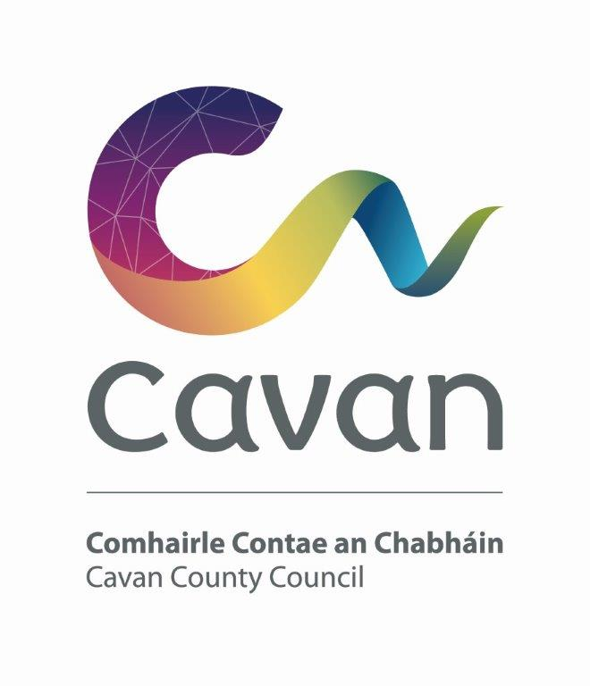

Cavan County Council

Cavan - Belturbet Municipal District

Minutes of Meeting held on 22nd April 2024

Presiding: Councillor (Cllr) Áine Smith, Cathaoirleach

Present: Councillors John Paul Feeley, Brendan Fay, Peter McVitty, Madeleine Argue and Patricia Walsh

In attendance: Paul Mulligan, SEE, Cavan Belturbet Municipal District Office
Brendan Jennings, Director of Services, Cavan County Council

Also in attendance:
Derry Scanlon, Senior Executive Engineer.
Pat Gaynor, Senior Executive Engineer.
Karl Kelly, Business Advisor, LEO.
John Donohoe, Senior Executive Officer.
Seamus Enright, Anglo Celt.
Rosaleen Higgins, Assistant Staff Officer, Minute Taker.

A G E N D A/ CLÁR
- Confirmation of Minutes

To confirm Minutes of Monthly Meeting held on the 19th March 2024.
- Disclosure of Interests (Section 177 Local Government Act 2001)

Business prescribed by Statute, Standing Orders or Resolutions of the Council

- Confirmation of Minutes
Cllr Feeley proposed minutes of last meetings and Cllr Mc Vitty seconded.

Cllr Smith welcomed everyone to the meeting in Irish and the meeting proceeded.

All Councillors expressed their Sympathy to Cllr Mc Vitty on the sad loss of his brother.

- Executive items

Mr Scanlon gave a talk on the Part VIII below.
(i) To approve report in accordance with Part VIII of the Local Government (Planning & Development) Regulations 2001–2008 (Article 81) to undertake the following works at the former Dinkins Bakery on Main Street, Belturbet.

The proposal is for the following: Development of a new Community, Enterprise and Tourism Hub. The works include partial demolition works and partial retention and refurbishment works to the existing building on Main Street, and partial demolition and partial retention and refurbishment works to the building on Patrick Street.

The proposed development will consist of:
- Existing Dinkins Bakery Building: Demolition of rear extensions, refurbishment and upgrade works to original structure and new build extension to provide community and youth enterprise spaces and ancillary facilities including toilets, storage, and new stairs.
- New Multi-Purpose Building: New build multi-purpose space
- New Alteration / Rebuild of Existing Stone Building: Demolition of roof structure, refurbishment/rebuild and upgrade works to existing two storey structure and new build three storey extension to provide meeting, offices, remote working spaces and ancillary facilities including toilets, storage, plant room, new stairs and elevator.
- New Internal and External Signage
Report attached.
- Site Works: Site development works, including archway access from Main Street/Patrick Street, external hard and soft landscaping, lighting, bin storage, common and communal open areas, bicycle parking, and all associated site services above and below ground.

Cllr Fay proposed the grants and Cllr Feeley seconded. Cllr Fay praised Mr. Scanlon for his hard work.

(ii) Discretionary Municipal District Grants John Donohoe SEO C&E
Mr Donohoe presented his report and stated they had an amount of €120,000 to allocate.

Other Items:
(i)The taking in charge of 2 housing estates within the MD.
(a) Station Lane, Cavan
(b) Drumglen Drive, Cavan
Pat Gaynor, SEE Panning
Mr Gaynor gave a talk on the estates we are taking in charge. Proposed by Cllr Fay and seconded by Cllr McVitty and Cllr Walsh.

(ii) Presentation Karl Kelly, Business Advisor LEO

Mr Kelly gave a talk on all the grants and supports available to small businesses in Cavan. Listed below are some of the grants and assistance available-
- Mentoring
- Training Programmes
- Training online voucher scheme
- Feasibility study grants.
- Priming grants.
Cllr Smith said it was fantastic to see all that was available for small businesses. She said we as Councillors will create more awareness of supports available.
Cllr Feeley welcomed Mr Kelly and commented that the IDA site nearly full and the council need to find ways to support, setting up of businesses.
Cllr Fay commented that people are afraid to go for grants, we need to make it easier for them and highlight supports available. He said small businesses are struggling, some with ESB bills of 2-3K a month.
All councillors agreed that the process of applying for grants can be difficult.
Mr Kelly said to contact him in the LEO office and he will take them through the process. He will ease their concerns. It’s a free and hugely subsidised service and the benefits in the long run are worthwhile.
Mr Jennigs said in relation to a new IDA space, the challenge is finding and buying land.
Mr Kelly concluded by asking Councillors to “get the word out” about all the supports available.
- Road Works Programme update Paul Mulligan

Mr Mulligan presented his report detailing the Restoration Improvement Programme for 2024. List below.

Mr Mulligan thanked all his staff for their good work.
Cllr Smith thanked Mr Mulligan and his great report. Very happy to see works starting on Loreto Road, Killymoriarty, Templeport and Kilsob.
All councillors commended the works done. Cllr Argue joked Mr Mulligan should join a camera club, brilliant photos in report.
Some councillors commented pity not more funding to get more roads fixed.

Members Items
- Speed management in Belturbet especially, area from centra into town.
Cllr Fay

Cllr Fay expressed his concern at the speed of motorists on approach roads into Belturbet town. He accepts that people must take ownership of their driving behaviour, he asked could the council intervene.
All Councillors supported the motion. Mr Mulligan said we will look at it.

- Repair to Milltown playground. Cllr Fay

Cllr Fay said there are two or three massive holes under the zipline in the playground. He asked the council to carry out urgent repairs.
All councillors supported the motion. Mr Mulligan noted the issue.

- Safety measures on the R201 from N87 into Milltown. Cllr McVitty

Cllr Mc Vitty highlighted a potential danger in that motorists may not be able to identify the road end, on approach to Milltown Village after recent cutting left an area to the side of the R201 bereft of hedging. He said a barrier would be a great help.
Mr Mulligan said it was an issue that council staff will look at. There are contractors in the county at present assessing such needs.
Cllr Fay had contact from the public too in relation to this.
All councillors support the motion.

- Local link for Milltown Village. Cllr Mc Vitty

Cllr Mc Vitty asked for the Local Link service to be extended to Milltown Village. He said people from Milltown have to go into Killeshandra or Belturbet to connect. All councillors supported the motion. Mr Mulligan said we would contact local link to find out.

- School holidays, food poverty. Cllr Walsh

Cllr Walsh welcomes free hot meals for all National School children. But she pointed out that during the school holidays no hot meals. A national approach is needed. No child should go hungry.
All councillors supported the motion. Cllr Fay commented he delivered food to people during Covid. He still delivers to some people.

- Signage at Tomena Cllr Smith

Cllr Smith stated that a lot of work is taking place with the Active Travel Scheme, but still cars speeding in the village past St Mogues College and various busy junctions.
All councillors supported motion.
She also mentioned the pedestrian crossing at Tesco in Cavan Town. Is it a proper crossing, can it be raised up?
Cllr Walsh supported the motion.
Mr Mulligan said we would have a look at it.

Presentation to Councillor Argue.

Cllr Smith presented flowers and a gift to Councillor Argue as she is retiring from public life as after 25 years. Cllr Smith said, “we will miss you”. She mentioned how kind Councillor Argue was to her after she was co-opted onto the council after the death of her father Sean.
Cllr Walsh spoke of her time working with Councillor Argue. Cllr Argue was first elected in 1999. She said they were good friends despite their political differences. She said how much she will miss her, told her “to take it easy and sit back”. She wished Cllr Argues daughter, Niamh well.
Cllr McVitty said that 25 years went very quickly and spoke about how they worked as a team to get things done. He wished her good health and happiness.
Cllr Fay echoed these sentiments.
Cllr Feeley said Cllr Argue the “wisest person in the room” and wished her many years of retirement.
Mr Jennings said Cllr Argue was always nice to work with and made life easy. He hopes retirement goes well for her and Terry.
Mr Mulligan said it was an absolute pleasure working with Cllr Argue.

Cllr Argue was speechless, she joked they were talking about a different person. She said it was time to “call it a day”.
She thanked her fellow Councillors, the executive and the media. “I will miss you all”

Signed:----------------------------

Date:-----------------------------------

